

**Common Data Problems**

In this chapter, you'll learn how to overcome some of the most common dirty data problems. You'll convert data types, apply range constraints to remove future data points, and remove duplicated data points to avoid double-counting.

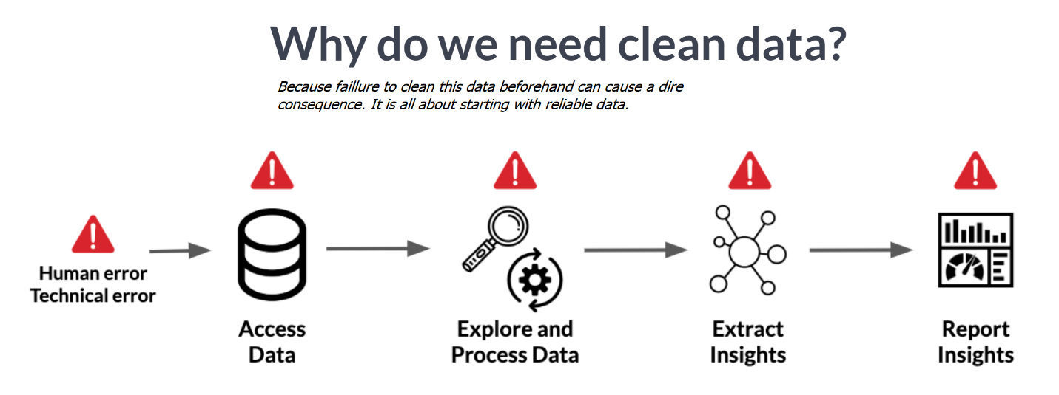

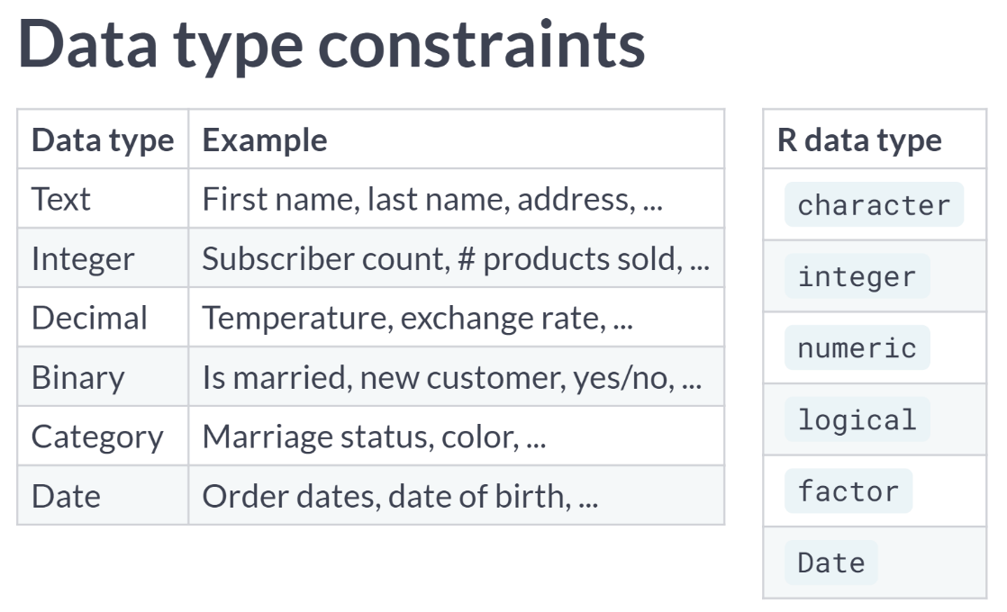

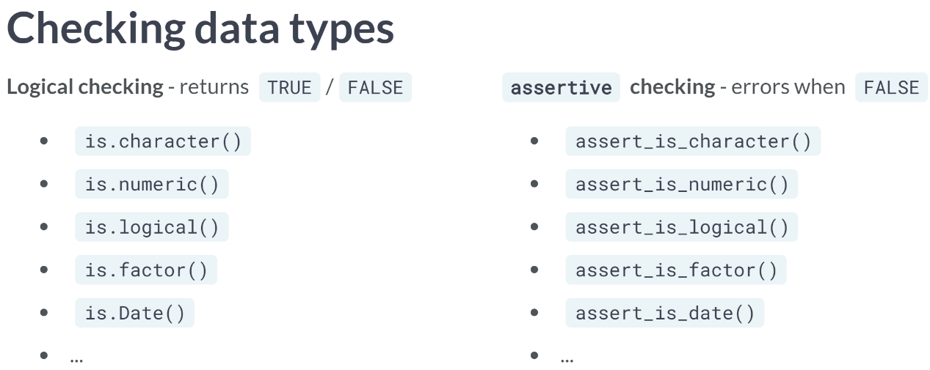

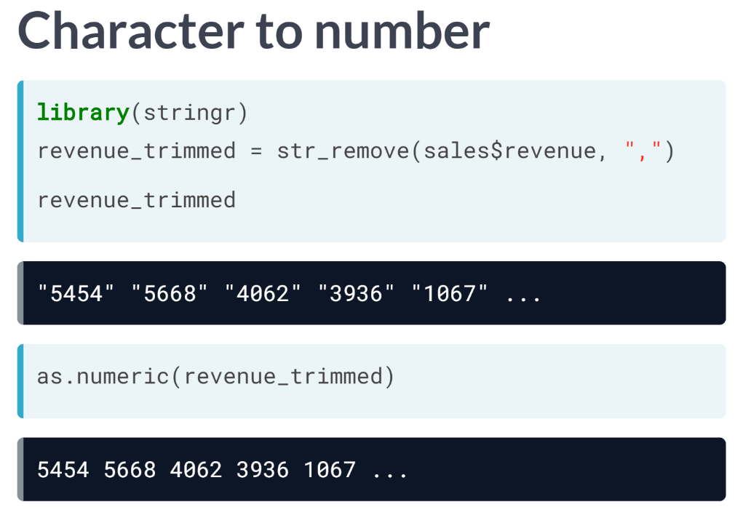  
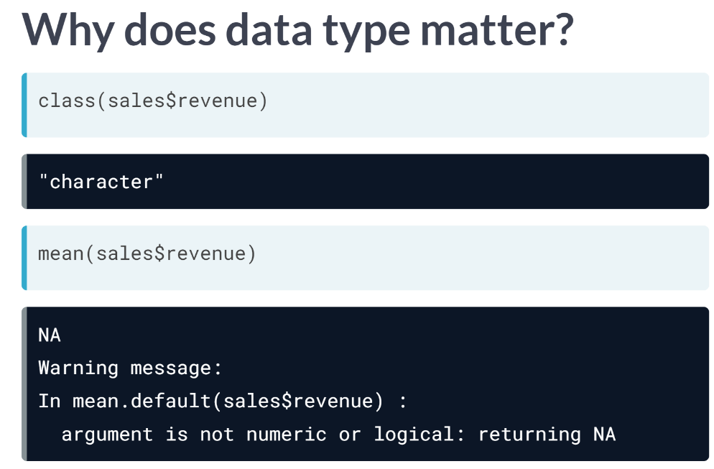

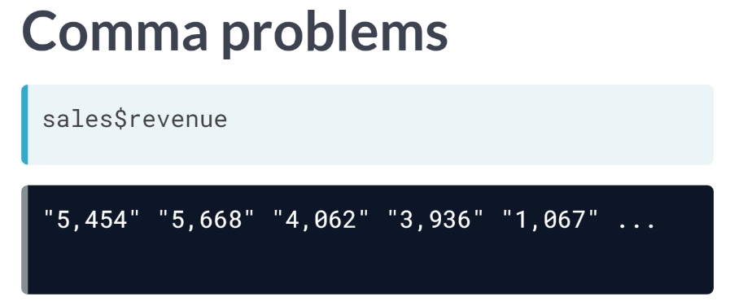  
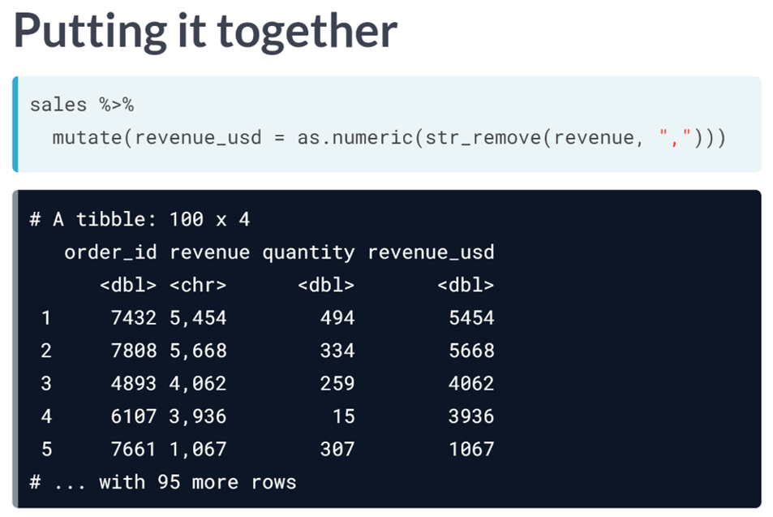

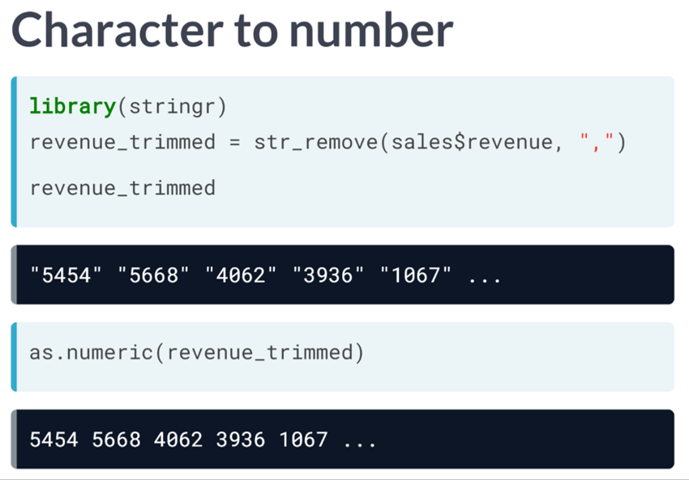

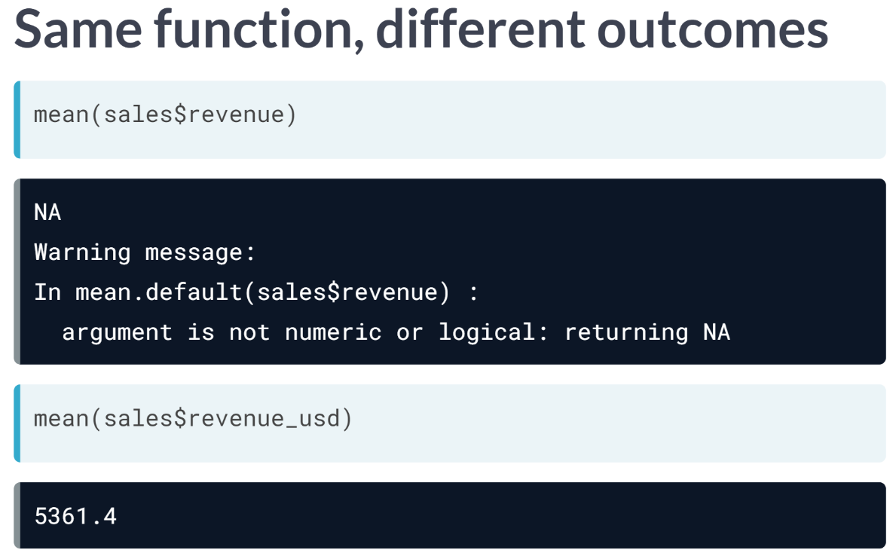  
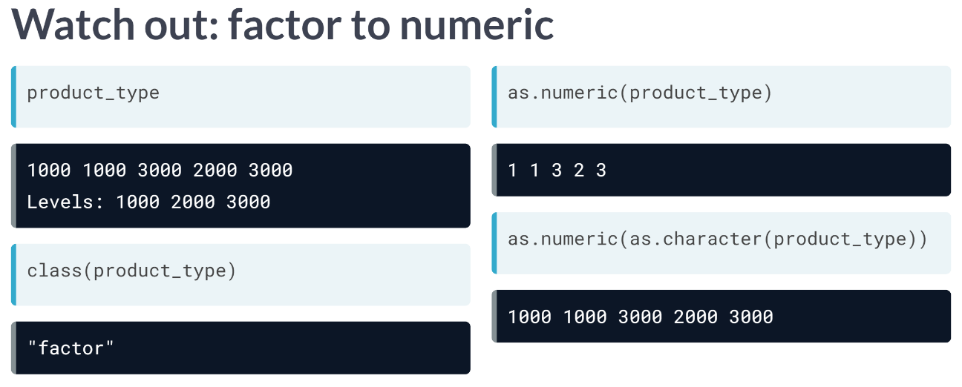

#### Common data types

Since different data types are treated and act differently, it's important to be able to identify the data type that's most suitable for the data you're working with. In this exercise, you'll learn match different data with the data type that makes the data easiest to process and extract insights from.  
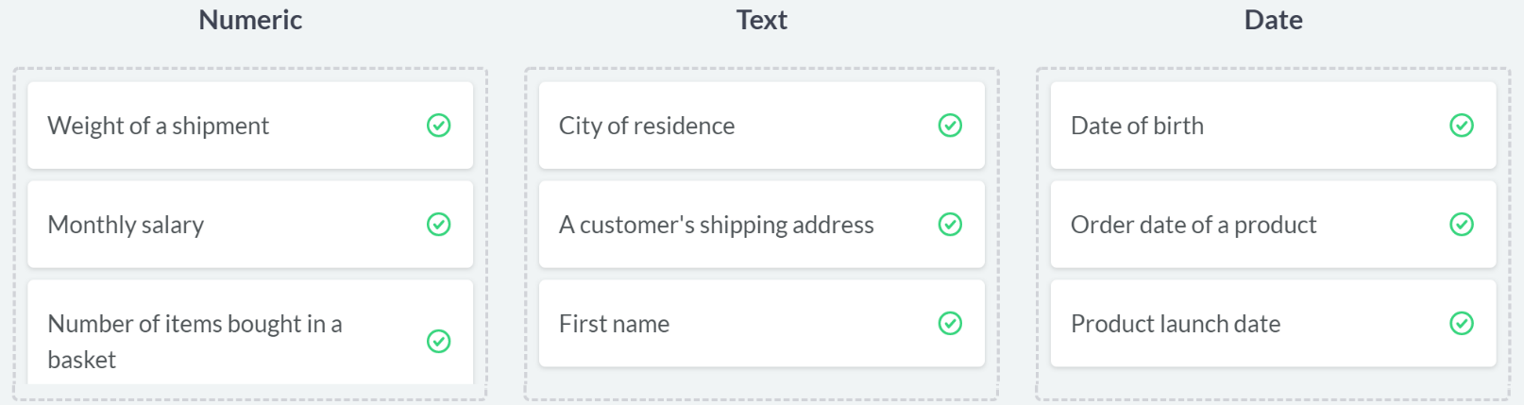

# Converting data types

Throughout this chapter, you'll be working with San Francisco bike share ride data called bike_share_rides. It contains information on start and end stations of each trip, the trip duration, and some user information.

Before beginning to analyze any dataset, it's important to take a look at the different types of columns you'll be working with, which you can do using glimpse().

In this exercise, you'll take a look at the data types contained in bike_share_rides and see how an incorrect data type can flaw your analysis.

dplyr and assertive are loaded and bike_share_rides is available.

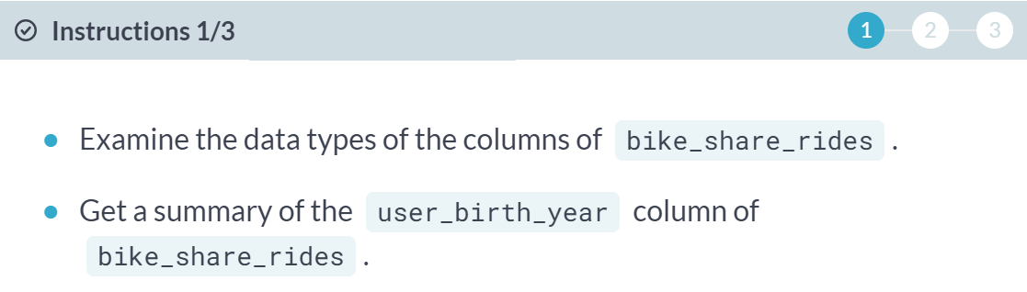

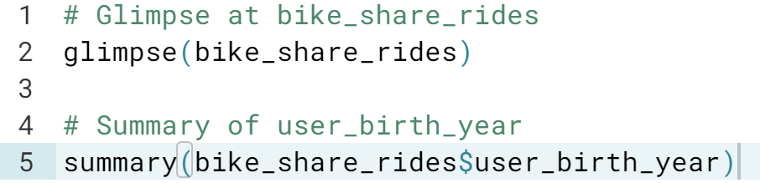

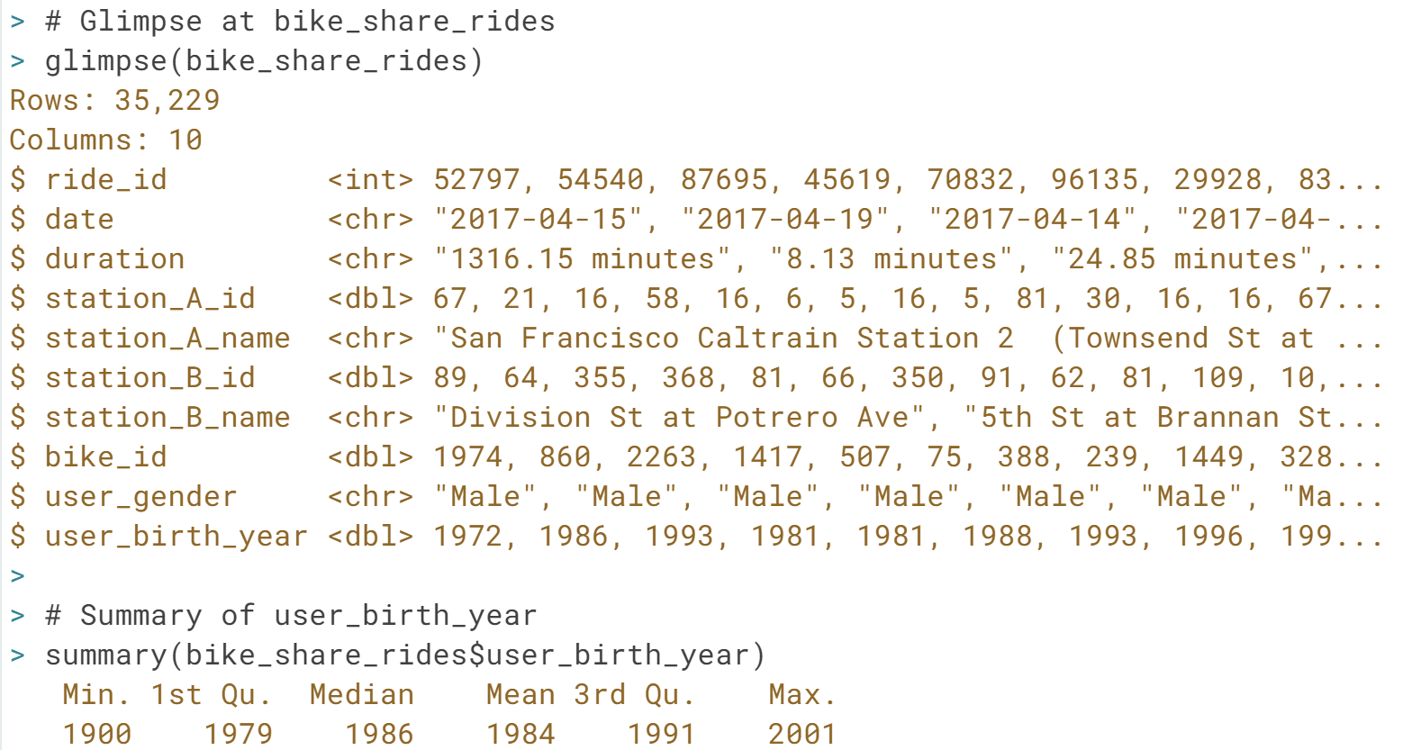

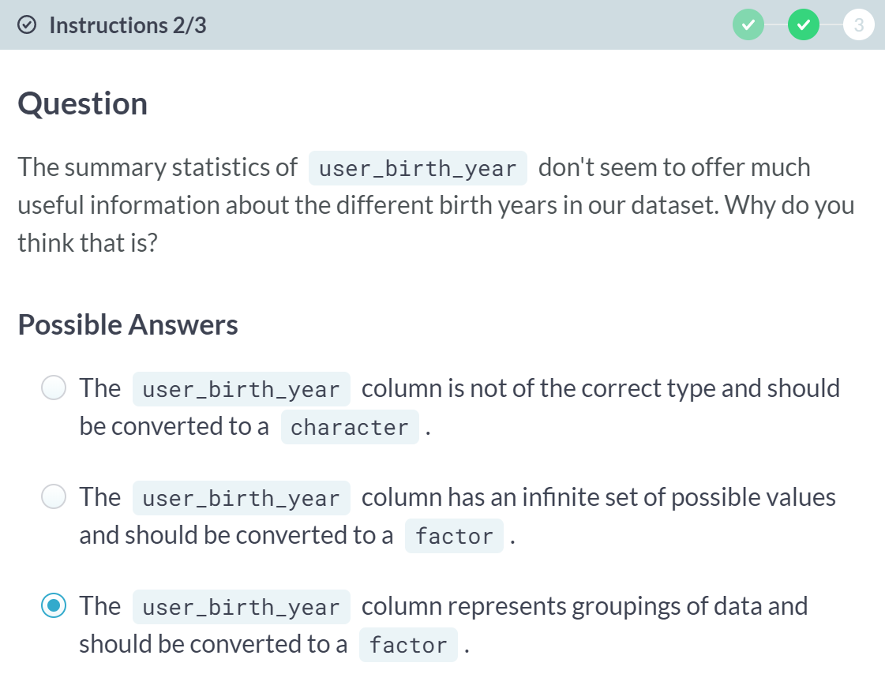

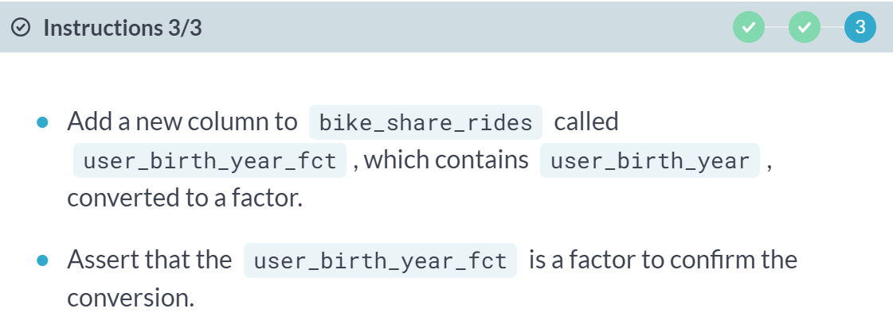

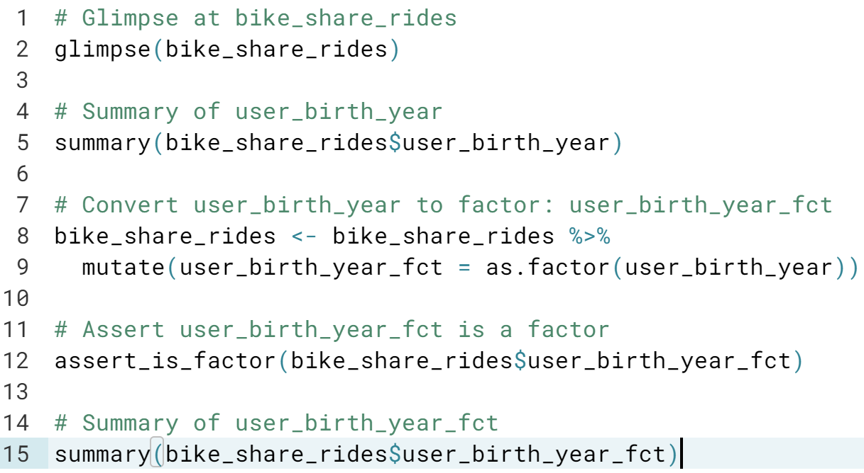

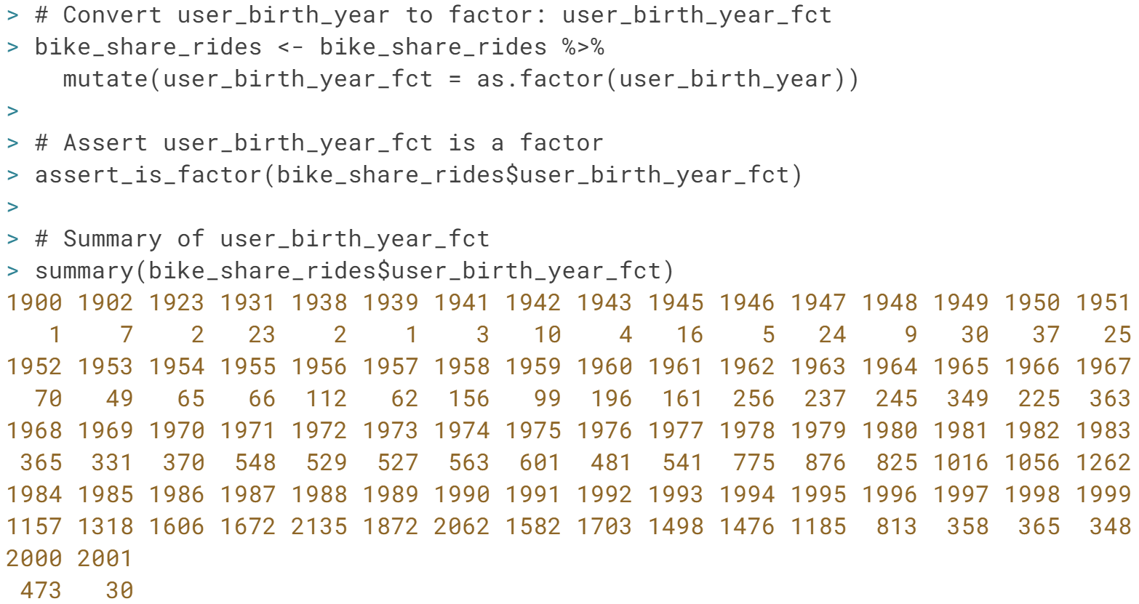

# Trimming strings

In the previous exercise, you were able to identify the correct data type and convert station_A_id to the correct type, allowing you to extract counts that gave you a bit more insight into the dataset.

Another common dirty data problem is having extra bits like percent signs or periods in numbers, causing them to be read in as characters. To be able to crunch these numbers, the extra bits need to be removed and the numbers need to be converted from character to numeric. In this exercise, you'll need to convert the duration column from character to numeric, but before this can happen, the word "minutes" needs to be removed from each value.

dplyr, assertive, and stringr are loaded and bike_share_rides is available.

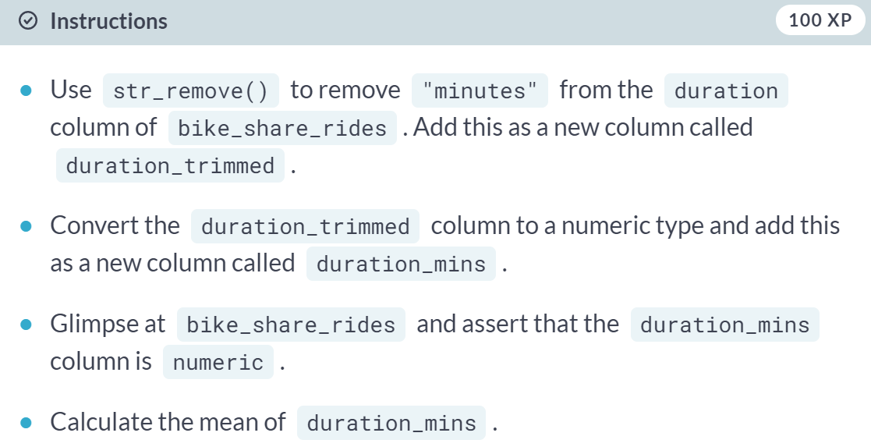

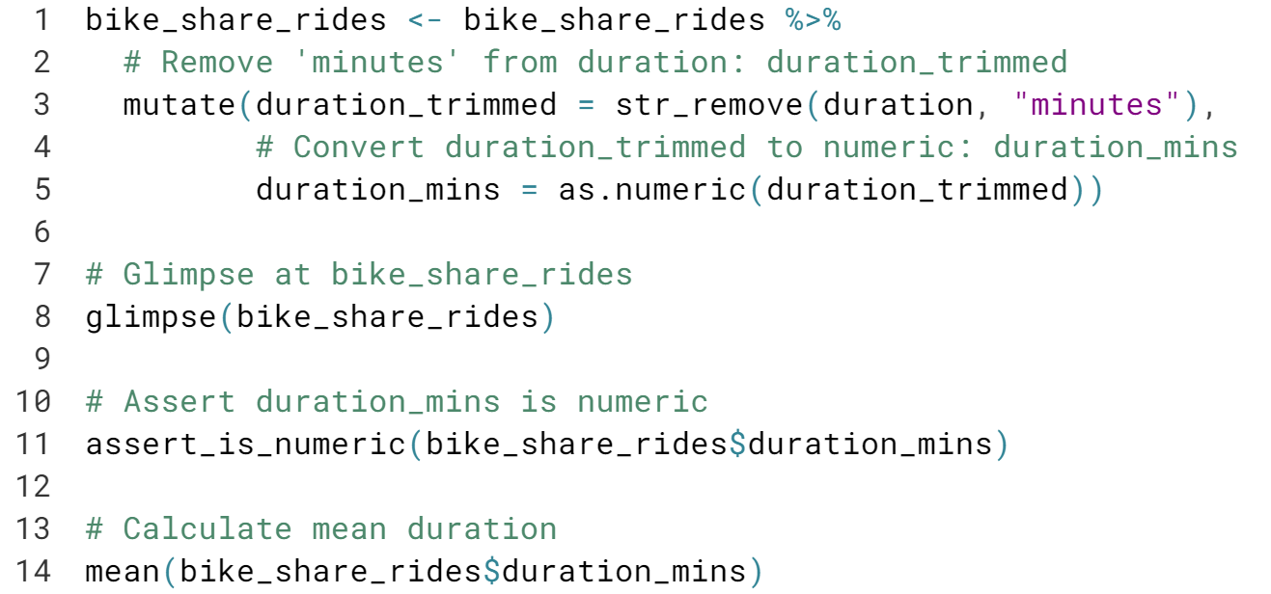

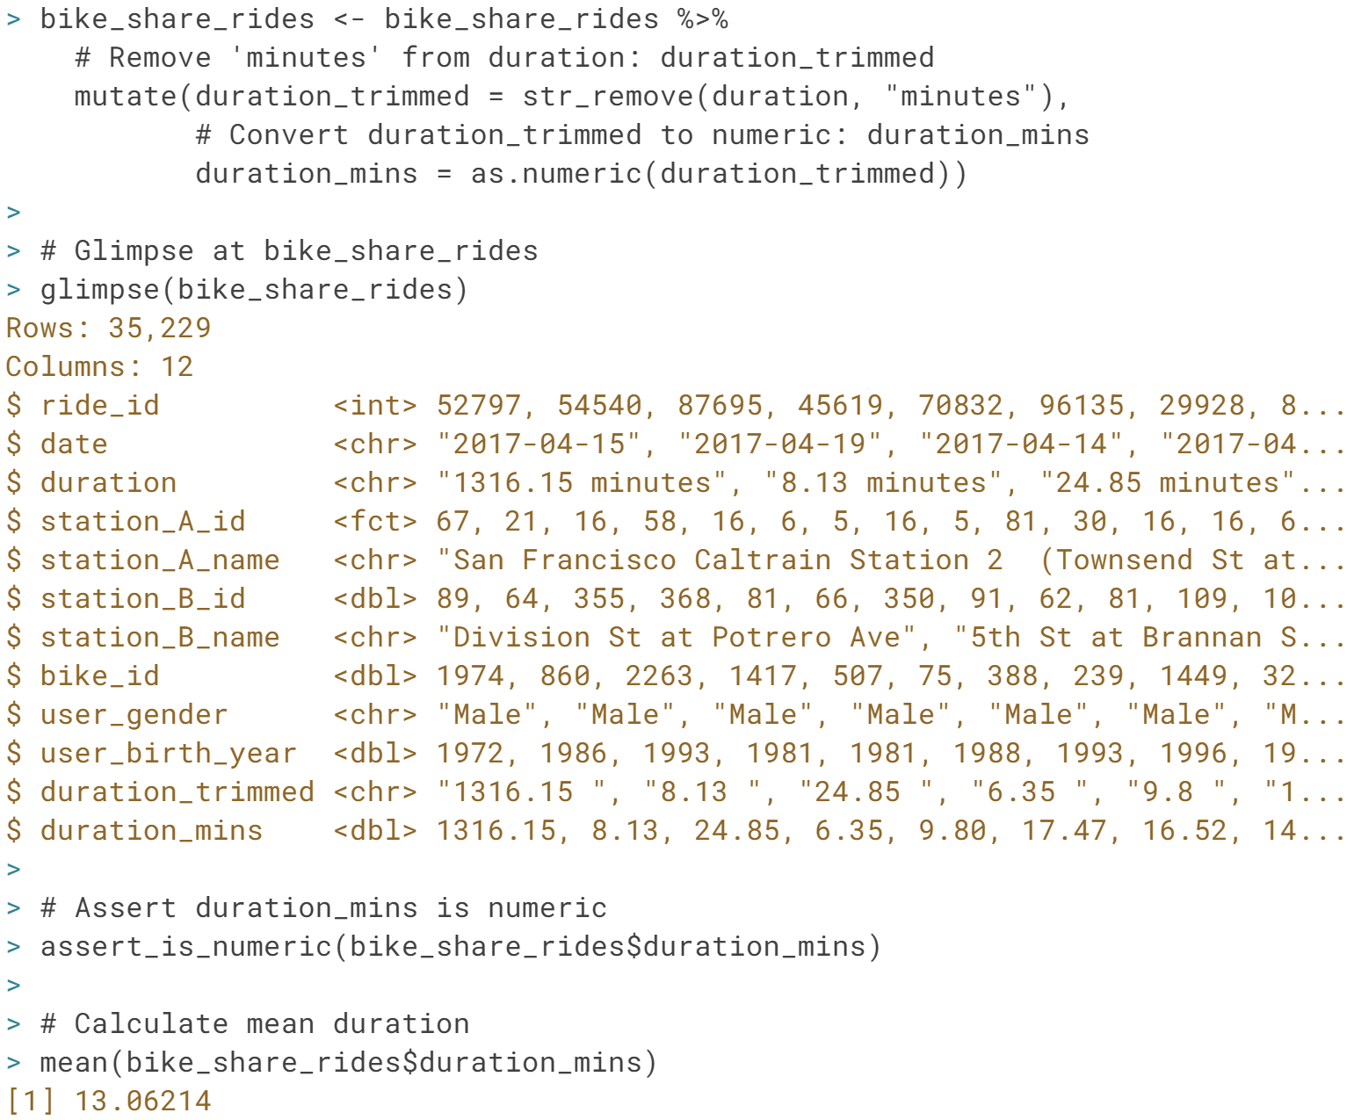

Great work! By removing characters and converting to a numeric type, you were able to figure out that the average ride duration is about 13 minutes - not bad for a city like San Francisco.



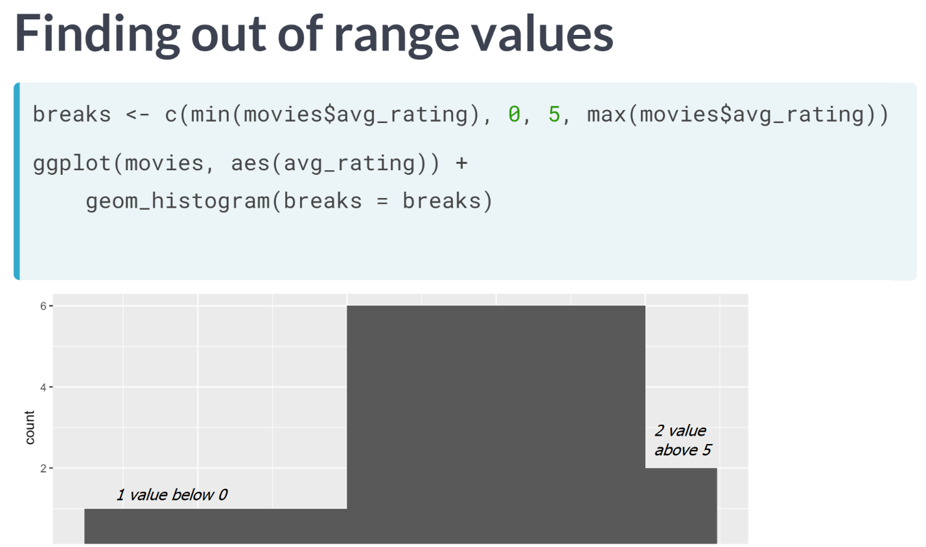

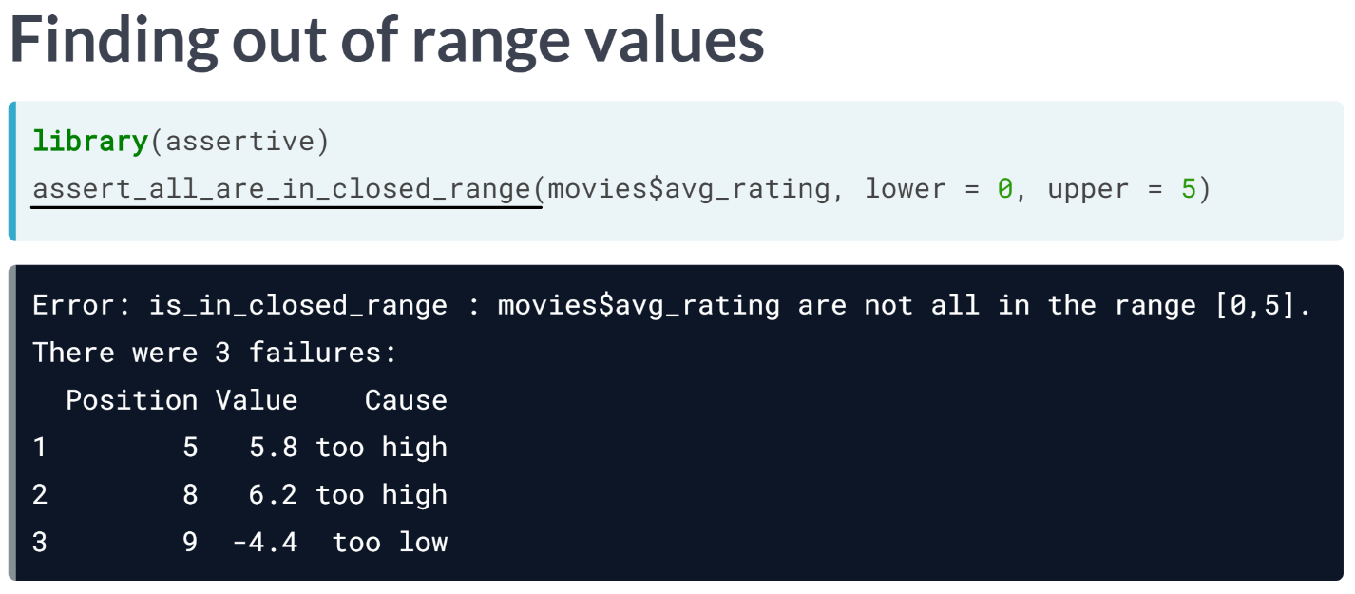

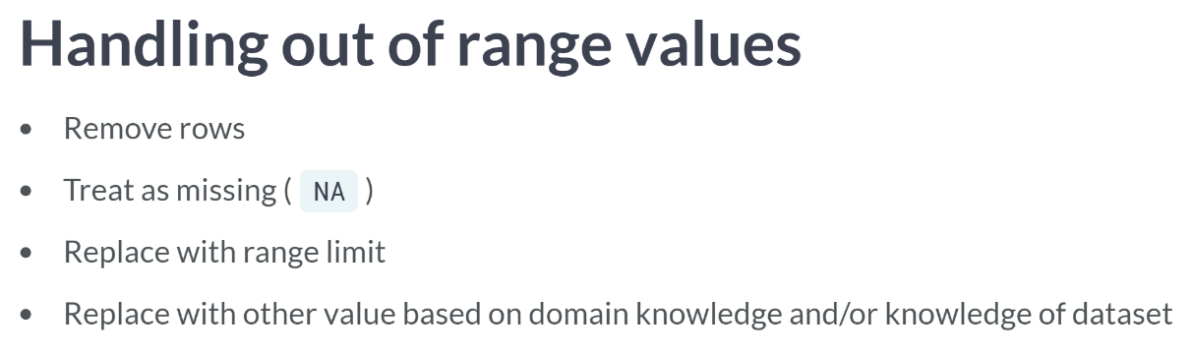

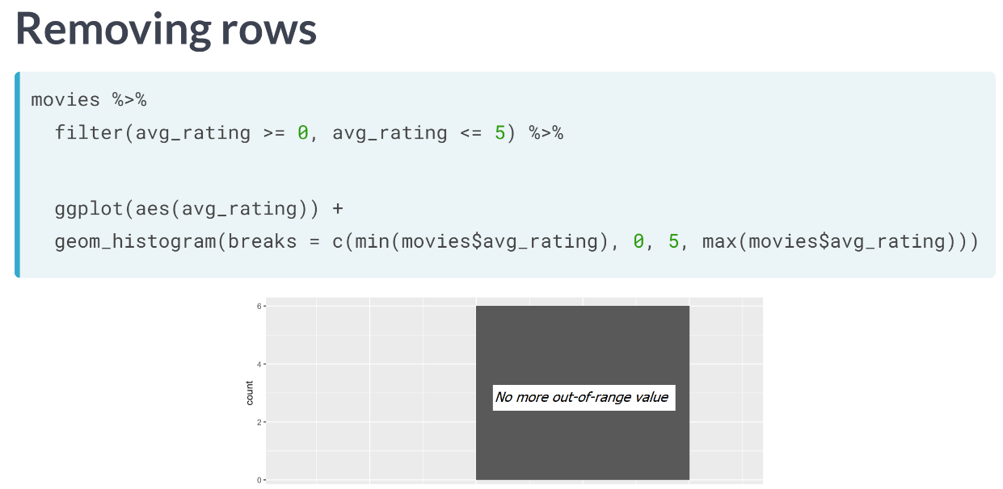

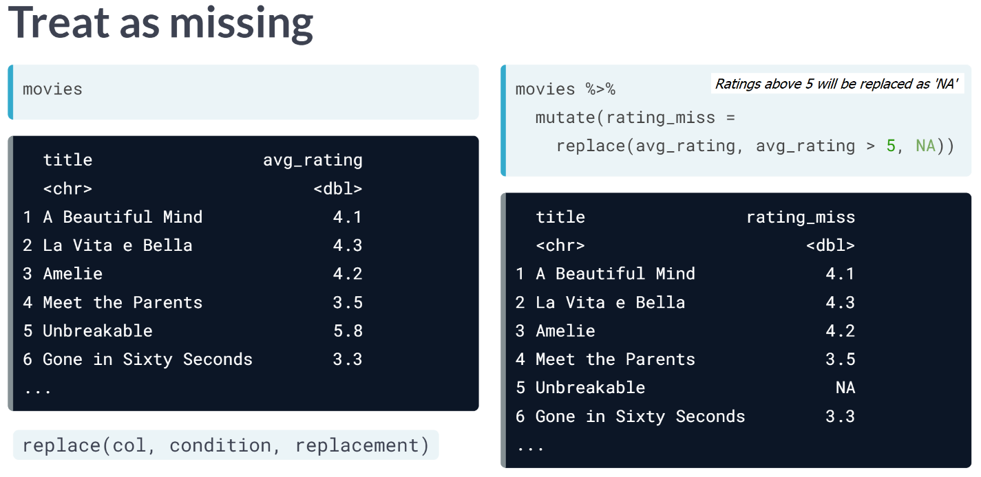

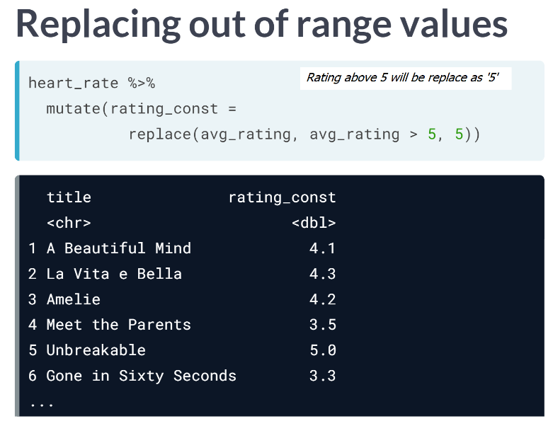

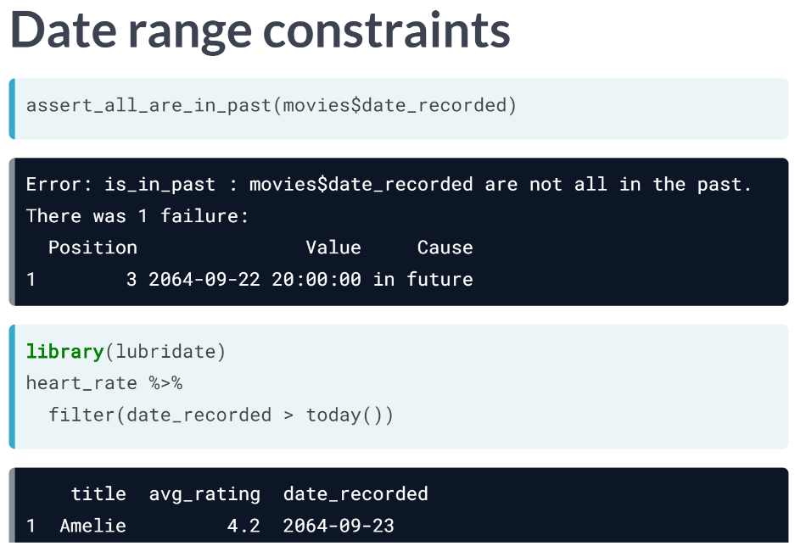

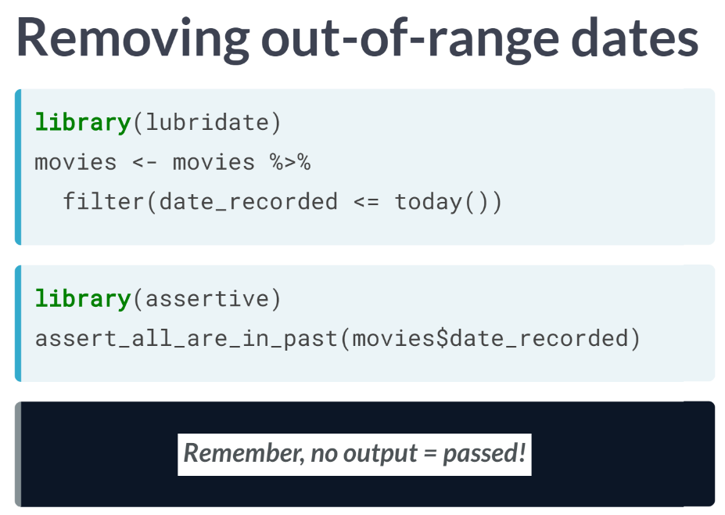

# Ride duration constraints

Values that are out of range can throw off an analysis, so it's important to catch them early on. In this exercise, you'll be examining the duration_min column more closely. Bikes are not allowed to be kept out for [**more than 24 hours**](https://help.baywheels.com/hc/en-us/articles/360033790932-How-long-can-I-keep-a-bike-out-), or 1440 minutes at a time, but issues with some of the bikes caused inaccurate recording of the time they were returned.

In this exercise, you'll replace erroneous data with the range limit (1440 minutes), however, you could just as easily replace these values with NAs.

dplyr, assertive, and ggplot2 are loaded and bike_share_rides is available.

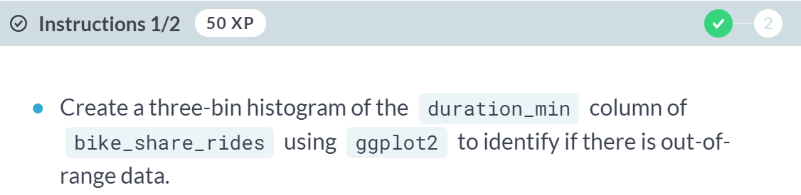  
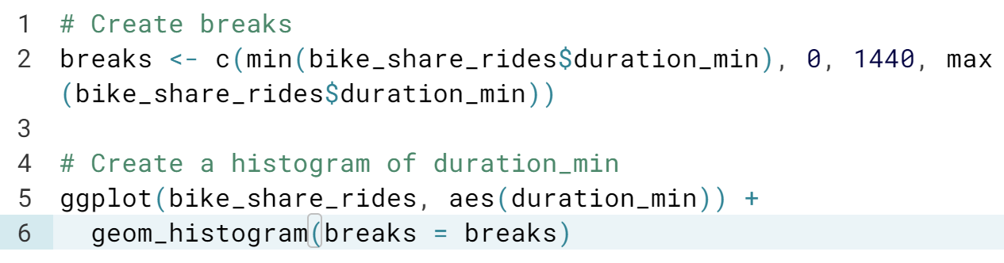  
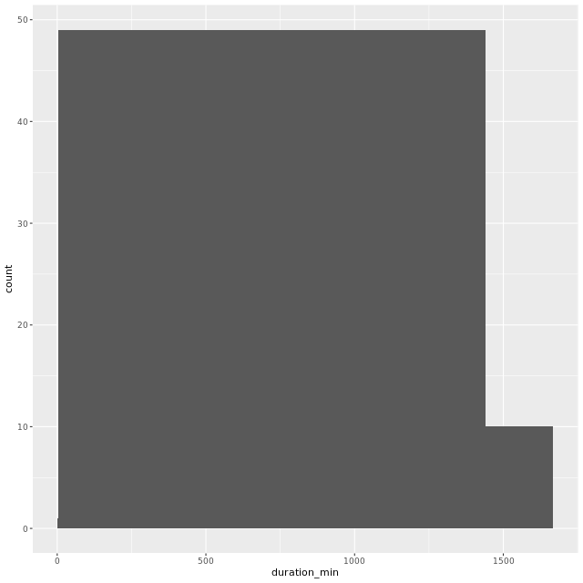

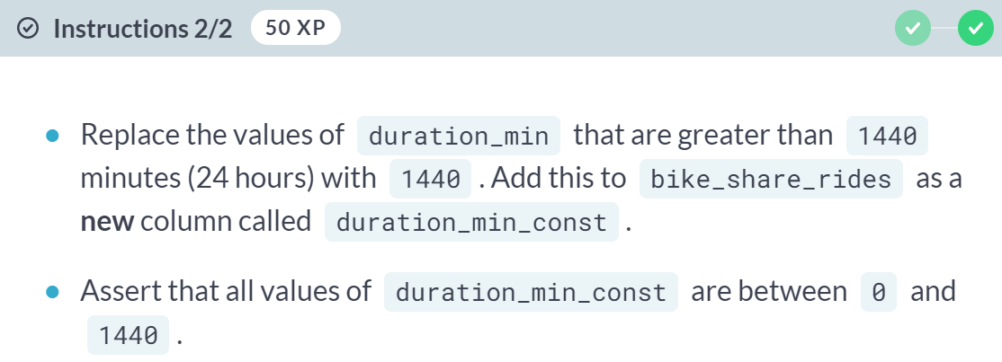

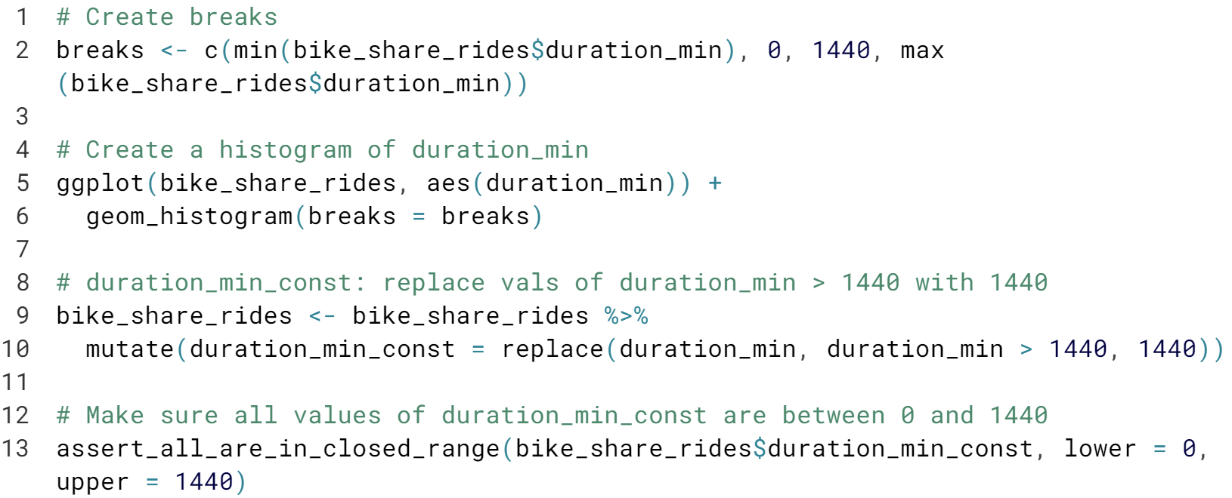



Radical replacing! The method of replacing erroneous data with the range limit works well, but you could just as easily replace these values with NAs or something else instead.

# Back to the future

Something has gone wrong and it looks like you have data with dates from the future, which is way outside of the date range you expected to be working with. To fix this, you'll need to remove any rides from the dataset that have a date in the future. Before you can do this, the date column needs to be converted from a character to a Date. Having these as Date objects will make it much easier to figure out which rides are from the future, since R makes it easy to check if one Date object is before (<) or after (>) another.

dplyr and assertive are loaded and bike_share_rides is available.

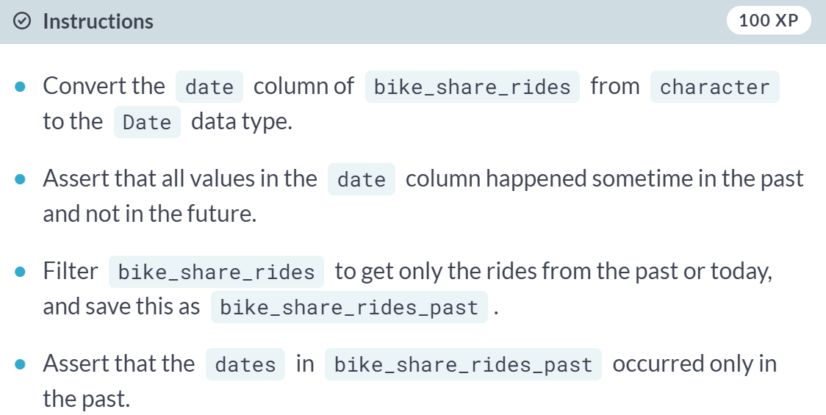

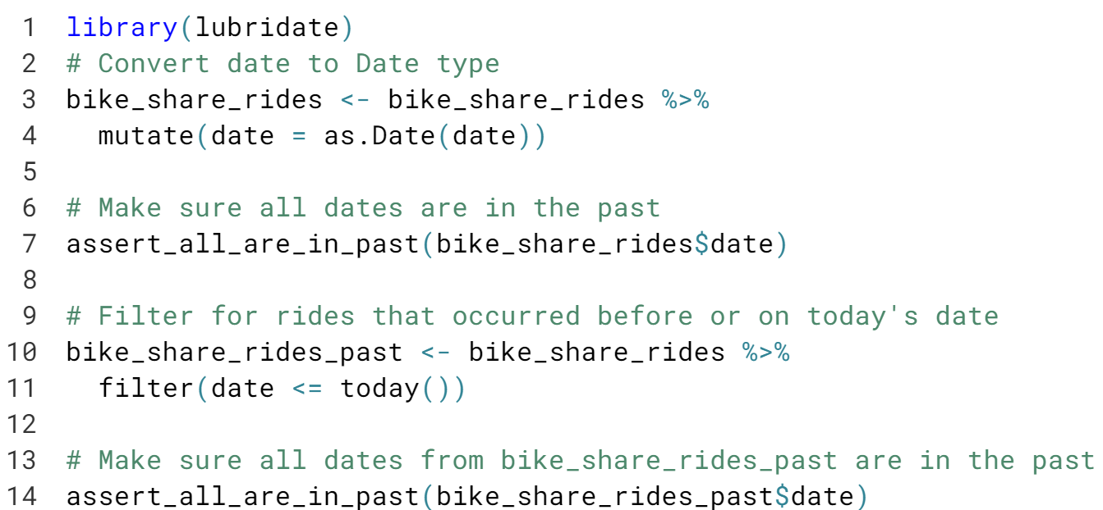

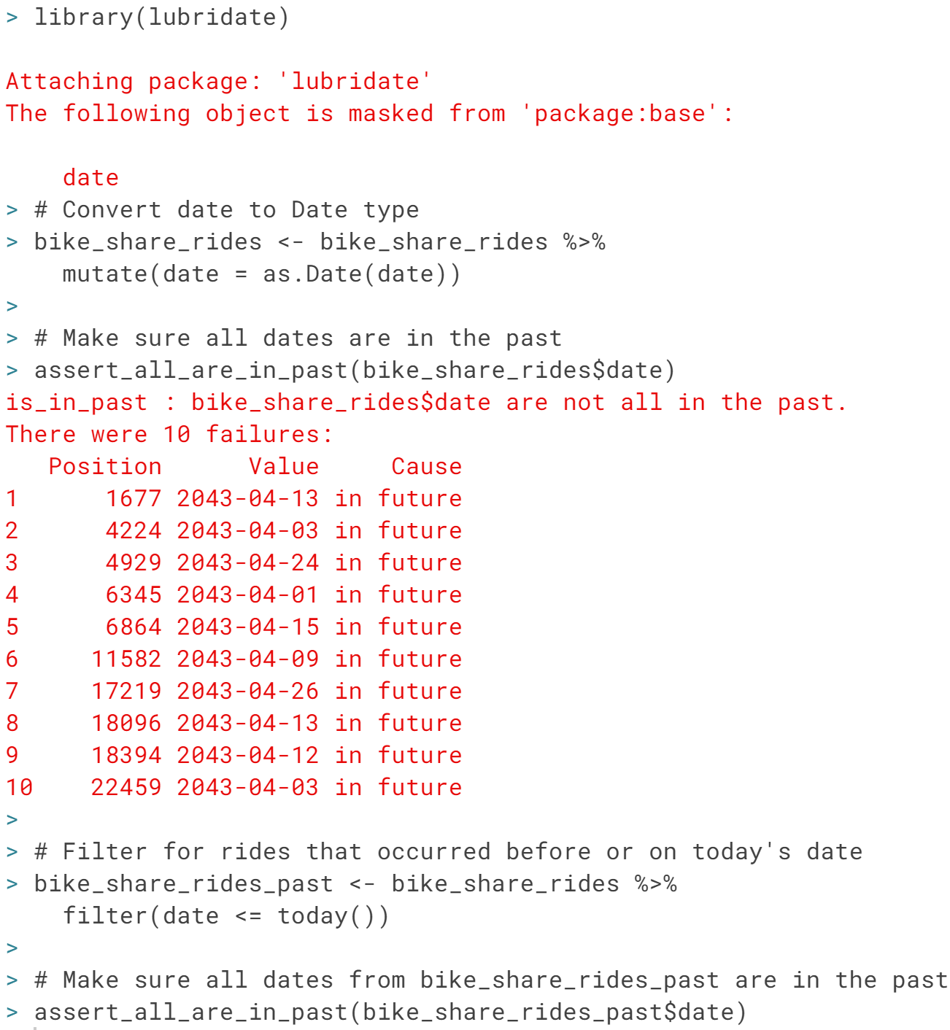

Fabulous filtering! Handling data from the future like this is much easier than trying to verify the data's correctness by time traveling.



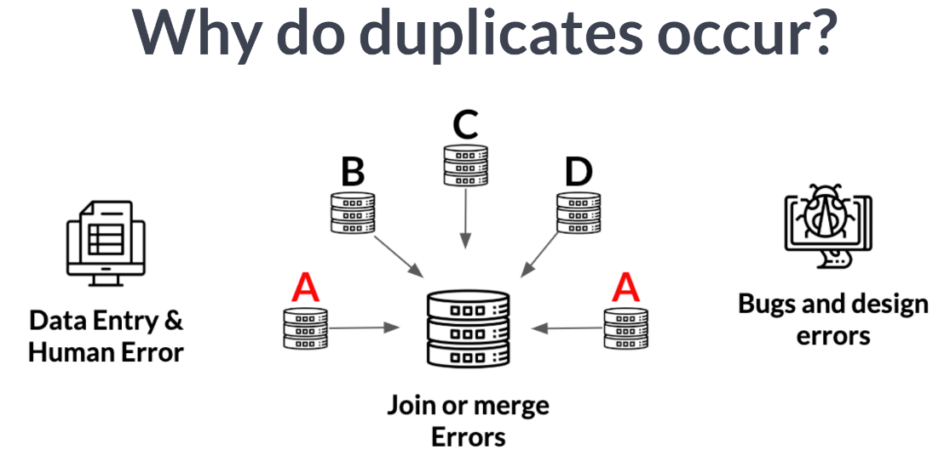

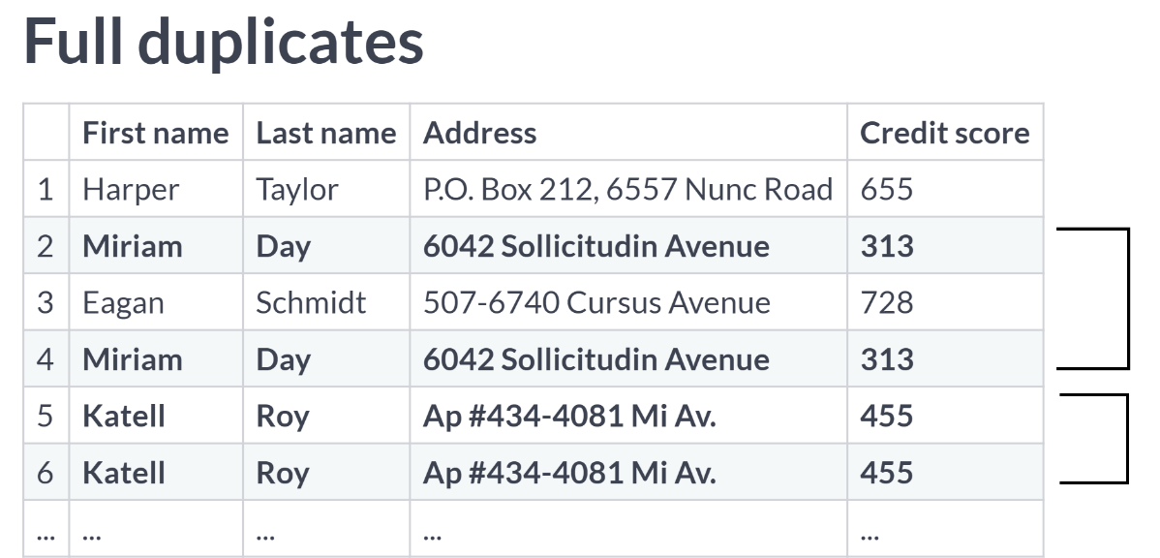

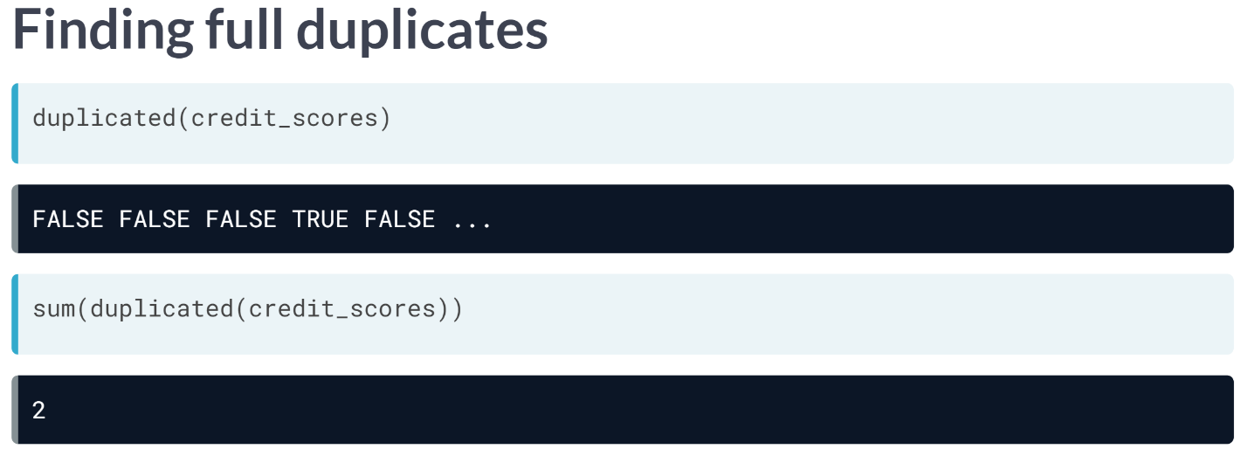

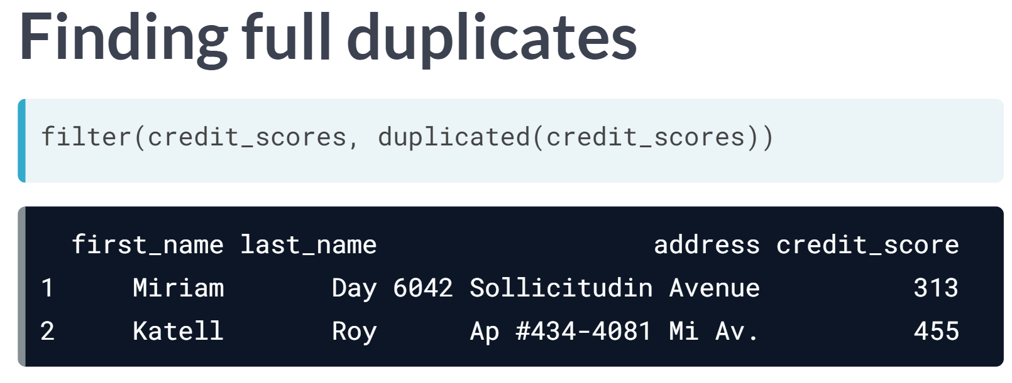

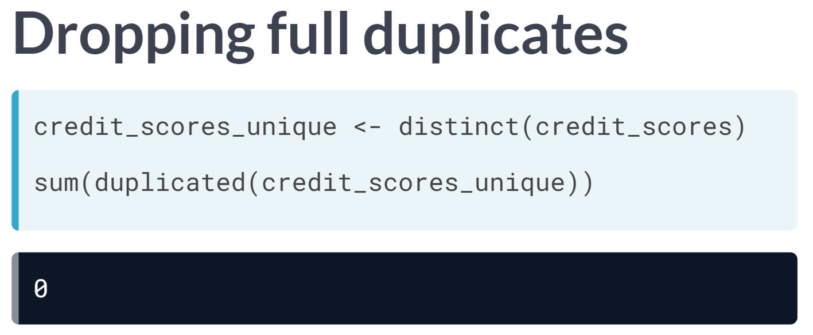

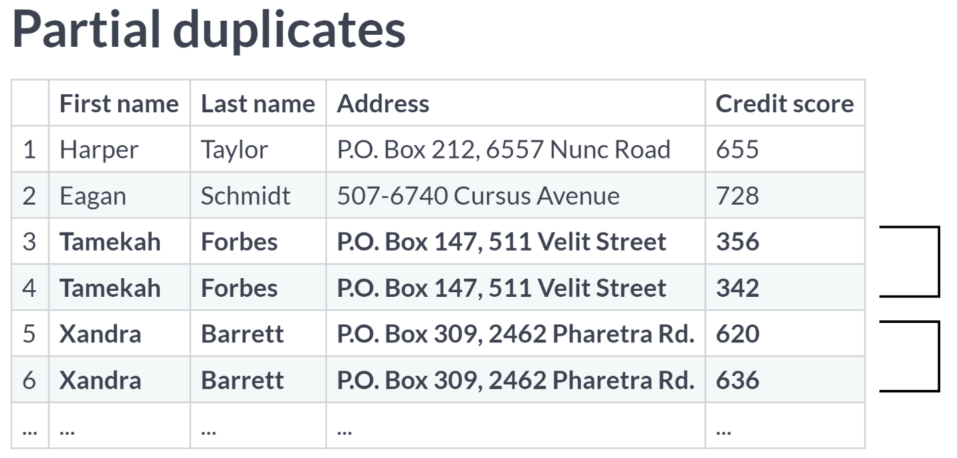

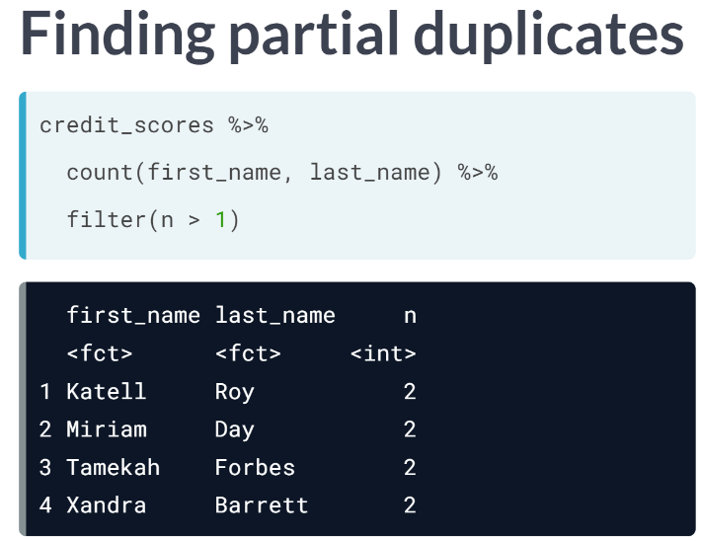

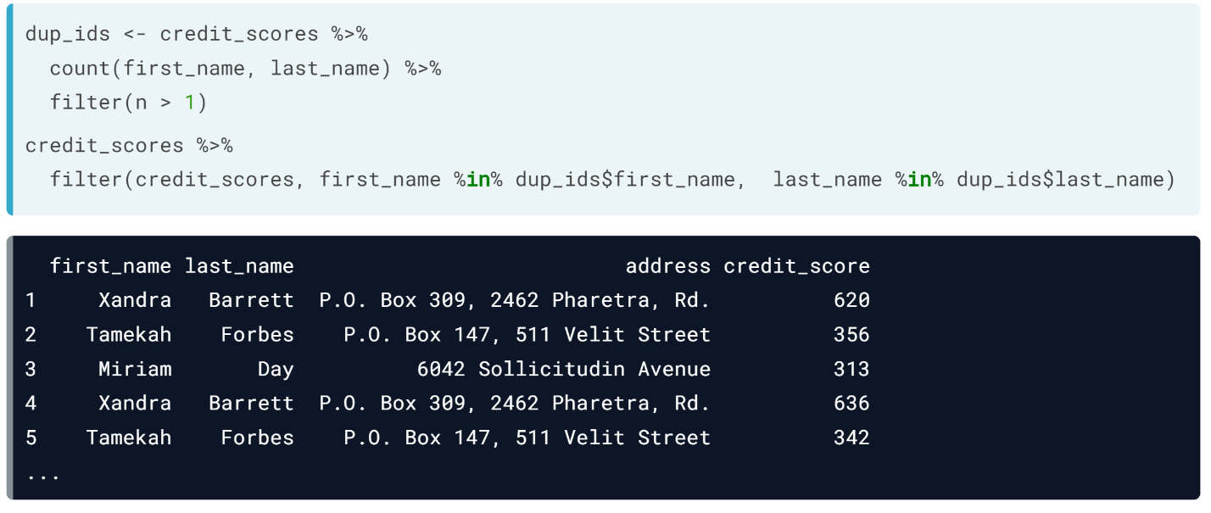

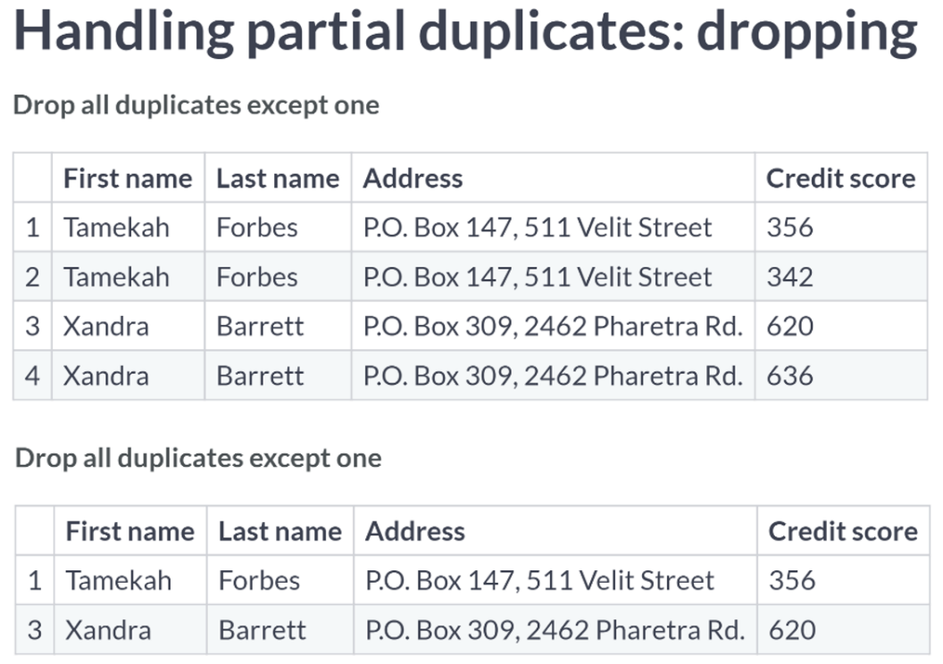

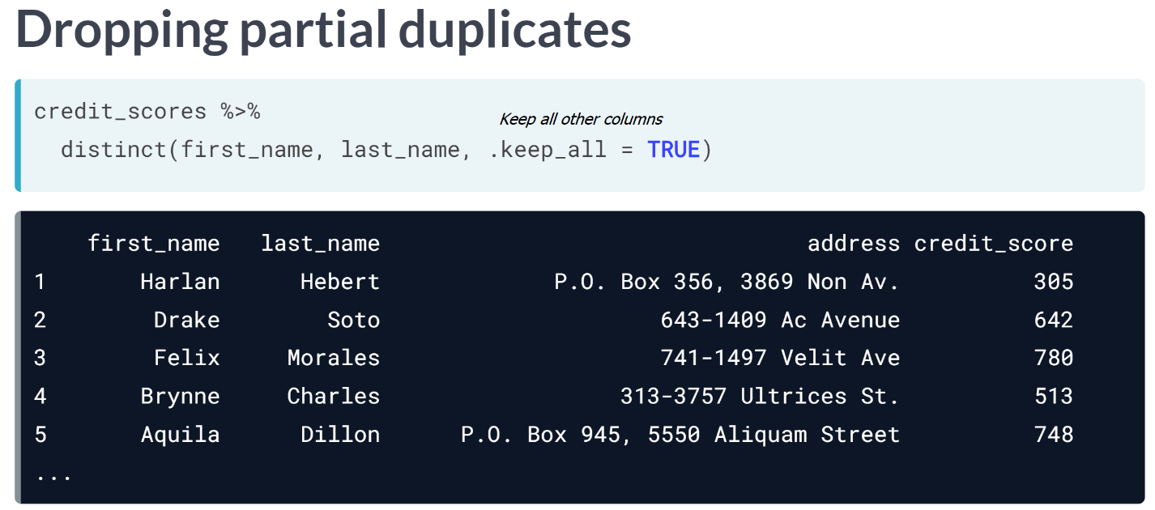

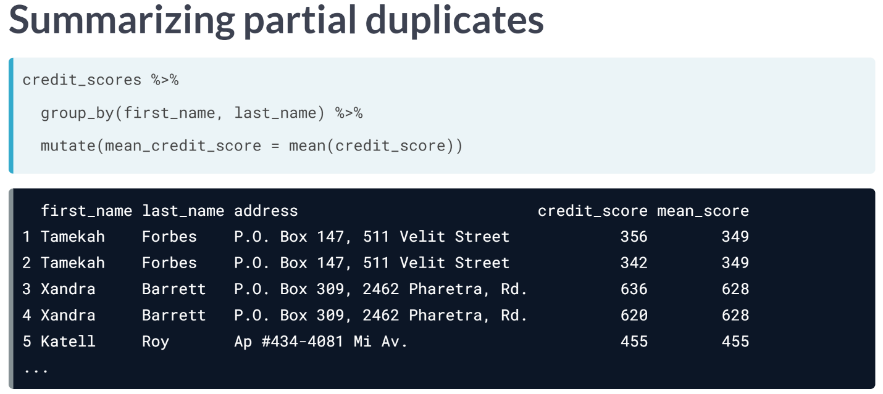

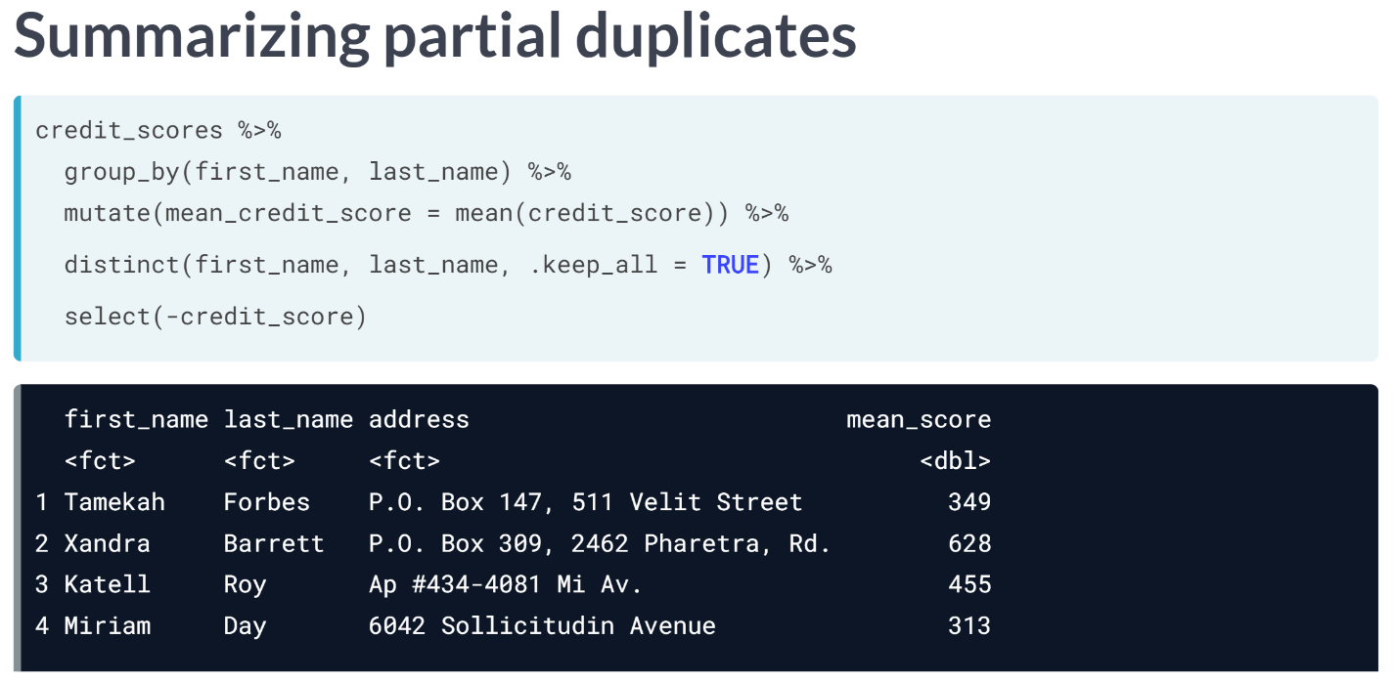

# Full duplicates

You've been notified that an update has been made to the bike sharing data pipeline to make it more efficient, but that duplicates are more likely to be generated as a result. To make sure that you can continue using the same scripts to run your weekly analyses about ride statistics, you'll need to ensure that any duplicates in the dataset are removed first.

When multiple rows of a data frame share the same values for all columns, they're full duplicates of each other. Removing duplicates like this is important, since having the same value repeated multiple times can alter summary statistics like the mean and median. Each ride, including its ride_id should be unique.

dplyr is loaded and bike_share_rides is available.

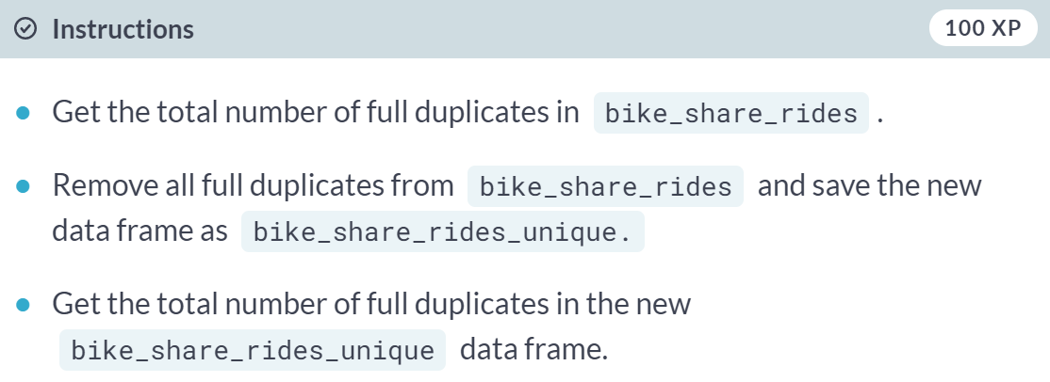

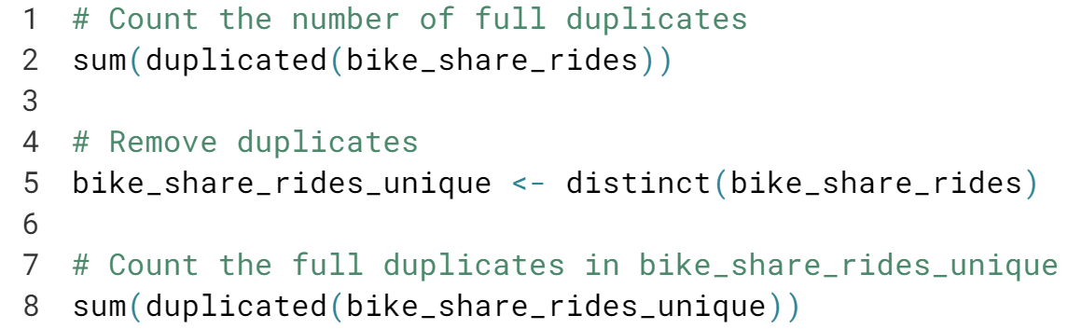

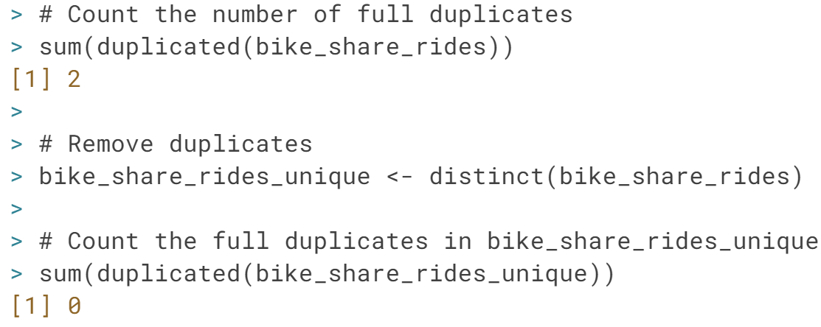

# Removing partial duplicates

Now that you've identified and removed the full duplicates, it's time to check for partial duplicates. Partial duplicates are a bit tricker to deal with than full duplicates. In this exercise, you'll first identify any partial duplicates and then practice the most common technique to deal with them, which involves dropping all partial duplicates, keeping only the first.

dplyr is loaded and bike_share_rides is available.

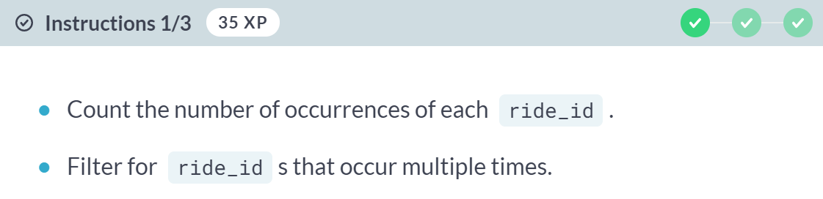

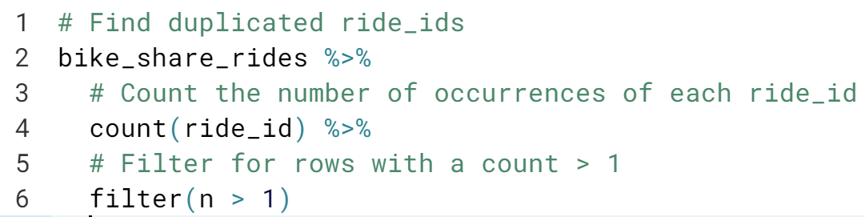

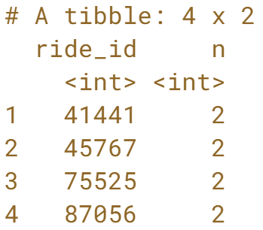

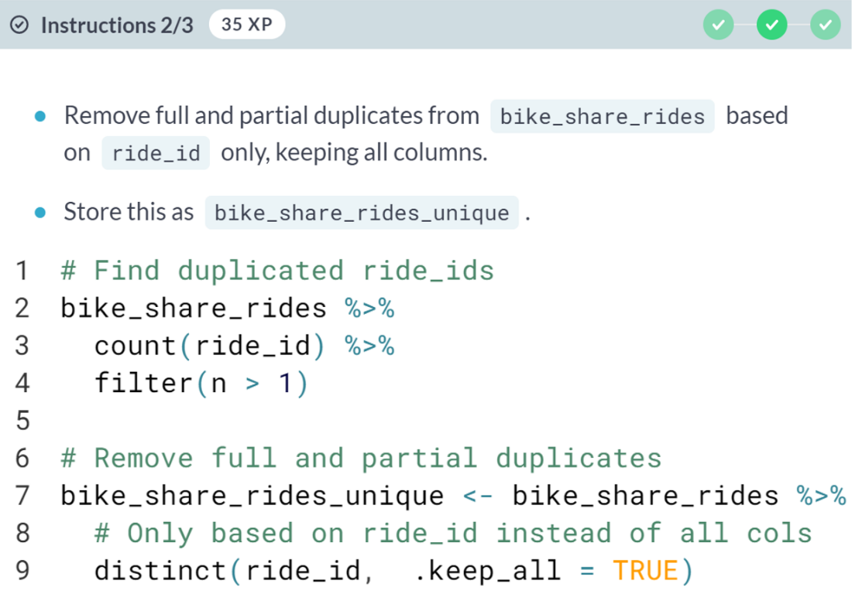

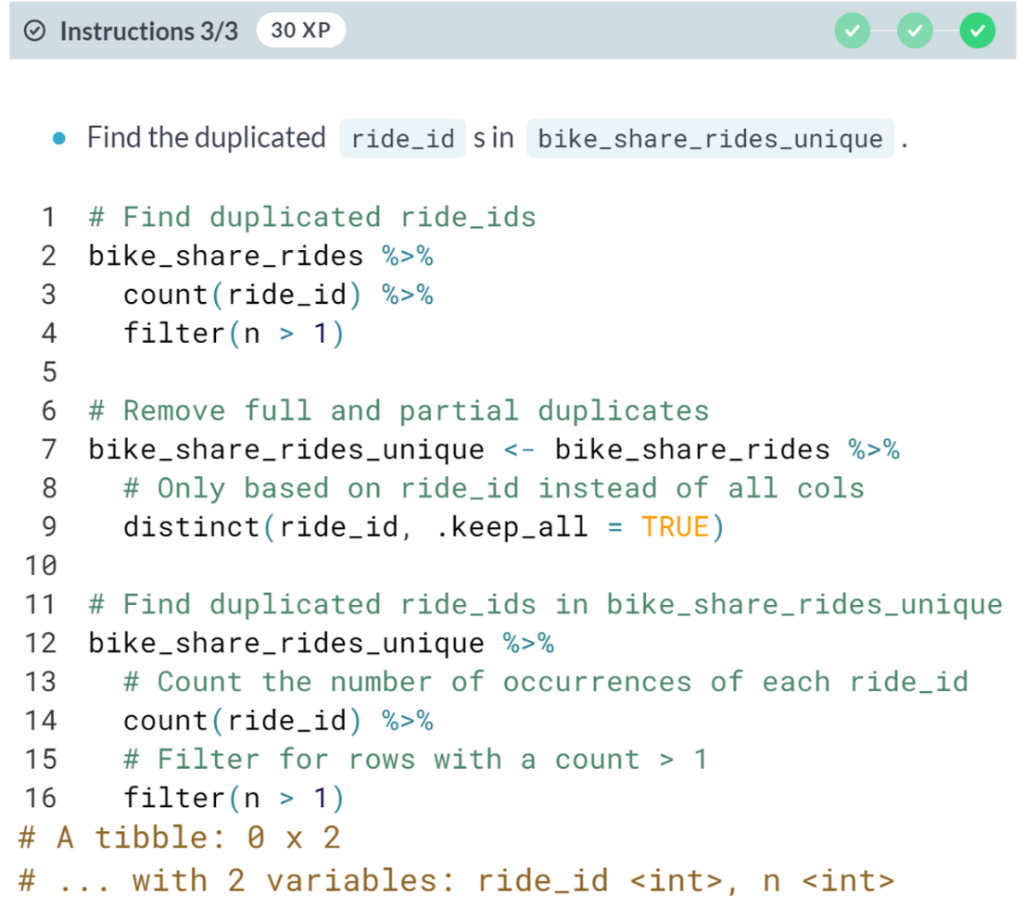  
It's important to consider the data you're working with before removing partial duplicates, since sometimes it's expected that there will be partial duplicates in a dataset, such as if the same customer makes multiple purchases.

# Aggregating partial duplicates

Another way of handling partial duplicates is to compute a summary statistic of the values that differ between partial duplicates, such as mean, median, maximum, or minimum. This can come in handy when you're not sure how your data was collected and want an average, or if based on domain knowledge, you'd rather have too high of an estimate than too low of an estimate (or vice versa).

dplyr is loaded and bike_share_rides is available.

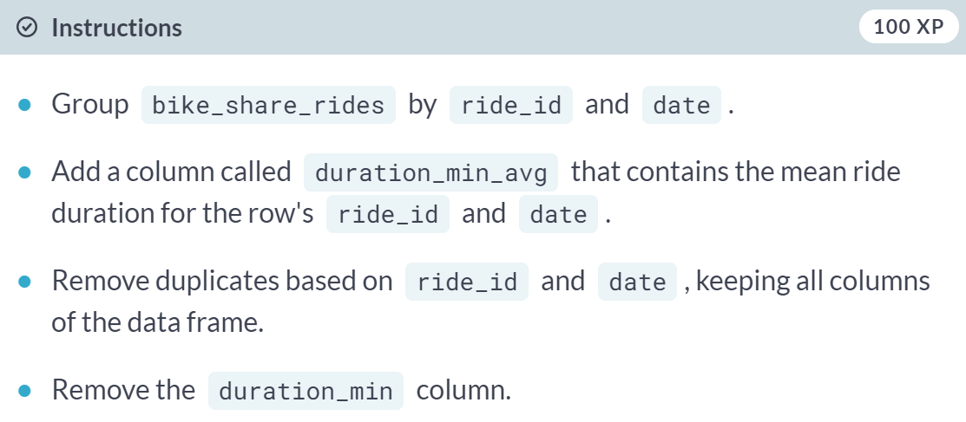

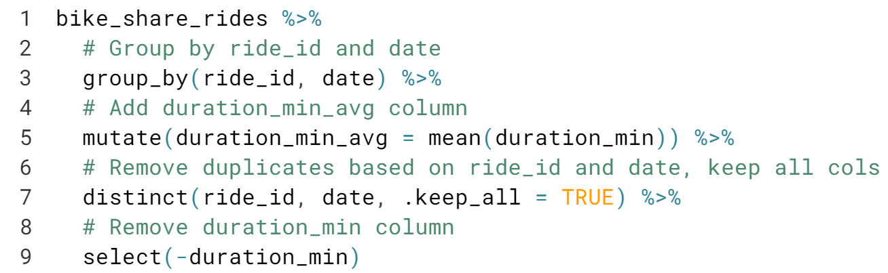

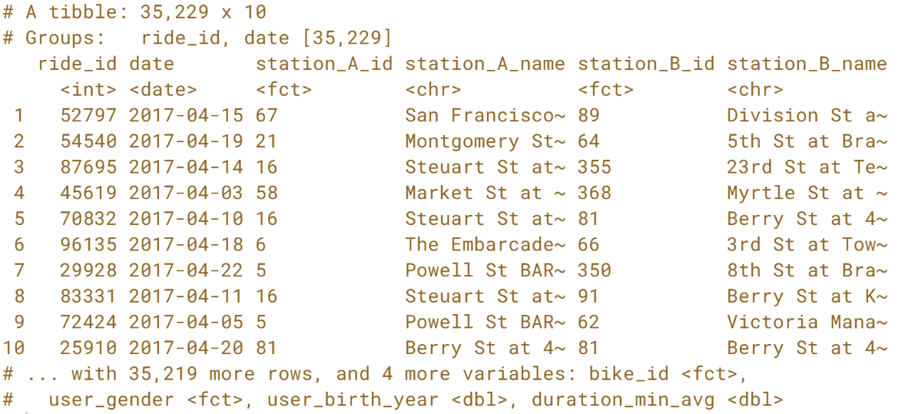  
Aggregation of partial duplicates allows you to keep some information about all data points instead of keeping information about just one data point.

#### Categorical and Text Data Categorical and text data can often be some of the messiest parts of a dataset due to their unstructured nature. In this chapter, you’ll learn how to fix whitespace and capitalization inconsistencies in category labels, collapse multiple categories into one, and reformat strings for consistency.

#### 

#### 

#### 

#### 

#### 

#### 

#### 

#### 

#### 

#### Members only

So far in the course, you've learned about a number of different problems you can run into when you have dirty data, including data type constraints, range constraints, uniqueness constraints, and membership constraints. It's important to be able to correctly identify the type of problem you're dealing with so that you can treat it correctly. In this exercise, you'll practice identifying these problems by mapping dirty data scenarios to their constraint type.

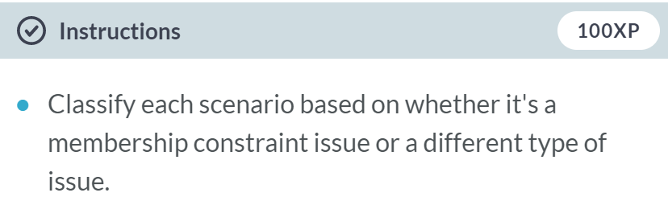  
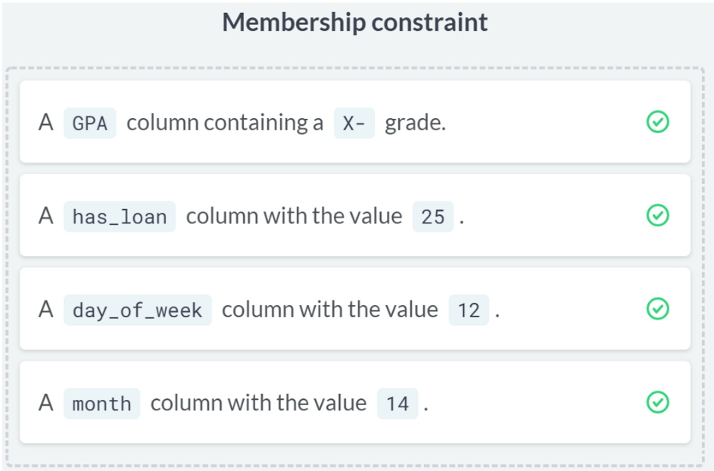

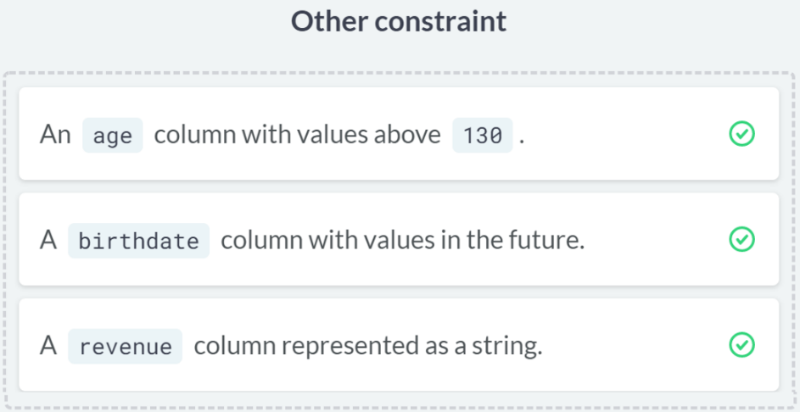

# Not a member

Now that you've practiced identifying membership constraint problems, it's time to fix these problems in a new dataset. Throughout this chapter, you'll be working with a dataset called sfo_survey, containing survey responses from passengers taking flights from San Francisco International Airport (SFO). Participants were asked questions about the airport's cleanliness, wait times, safety, and their overall satisfaction.

There were a few issues during data collection that resulted in some inconsistencies in the dataset. In this exercise, you'll be working with the dest_size column, which categorizes the size of the destination airport that the passengers were flying to. A data frame called dest_sizes is available that contains all the possible destination sizes. Your mission is to find rows with invalid dest_sizes and remove them from the data frame.

dplyr has been loaded and sfo_survey and dest_sizes are available.

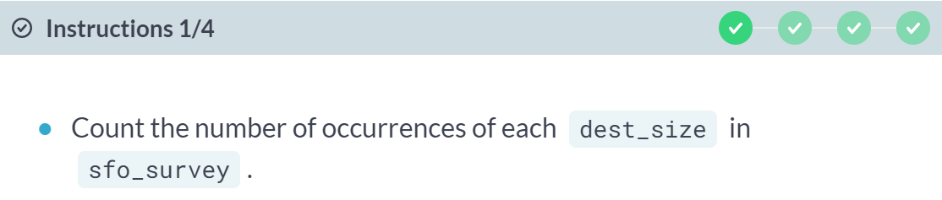

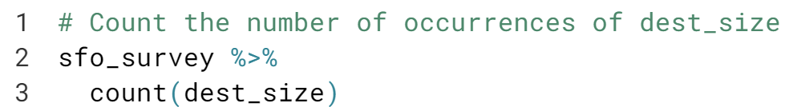

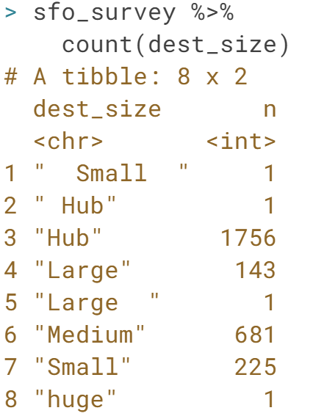

#### 

#### 

#### 

#### 

#### 

#### Anti-joins can help you identify the rows that are causing issues, and semi-joins can remove the issue-causing rows.

#### In the next lesson, you'll learn about other ways to deal with bad values so that you don't have to lose rows of data.

#### 

#### 

#### 

#### 

#### 

#### 

#### 

#### 

# Identifying inconsistency

In the video exercise, you learned about different kinds of inconsistencies that can occur within categories, making it look like a variable has more categories than it should.

In this exercise, you'll continue working with the sfo_survey dataset. You'll examine the dest_size column again as well as the cleanliness column and determine what kind of issues, if any, these two categorical variables face.

dplyr and is loaded and sfo_survey is available.

#### 

#### 

#### 

#### 

#### 

#### 

#### 

#### 

# Correcting inconsistency

Now that you've identified that dest_size has whitespace inconsistencies and cleanliness has capitalization inconsistencies, you'll use the new tools at your disposal to fix the inconsistent values in sfo_survey instead of removing the data points entirely, which could add bias to your dataset if more than 5% of the data points need to be dropped.

dplyr and stringr are loaded and sfo_survey is available.

#### 

#### 

#### 

# Collapsing categories

One of the tablets that participants filled out the sfo_survey on was not properly configured, allowing the response for dest_region to be free text instead of a dropdown menu. This resulted in some inconsistencies in the dest_region variable that you'll need to correct in this exercise to ensure that the numbers you report to your boss are as accurate as possible.

dplyr and forcats are loaded and sfo_survey is available.

#### 

#### 

#### 

#### 

#### 

#### 

#### 

#### Clean collapsing! You've reduced the number of categories from 12 to 9, and you can now be confident that 401 of the survey participants were heading to Europe.

#### 

#### 

#### 

#### 

#### 

#### 

#### 

#### 

#### 

#### 

# Detecting inconsistent text data

You've recently received some news that the customer support team wants to ask the SFO survey participants some follow-up questions. However, the auto-dialer that the call center uses isn't able to parse all of the phone numbers since they're all in different formats. After some investigation, you found that some phone numbers are written with hyphens (-) and some are written with parentheses ((,)). In this exercise, you'll figure out which phone numbers have these issues so that you know which ones need fixing.

dplyr and stringr are loaded, and sfo_survey is available.

#### 

#### 

#### 

#### 

#### 

#### 

#### Now that you've identified the inconsistencies in the phone column, it's time to remove unnecessary characters to make the follow-up survey go as smoothly as possible.

# Replacing and removing

In the last exercise, you saw that the phone column of sfo_data is plagued with unnecessary parentheses and hyphens. The customer support team has requested that all phone numbers be in the format "123 456 7890". In this exercise, you'll use your new stringr skills to fulfill this request.

dplyr and stringr are loaded and sfo_survey is available.

#### 

#### 

#### 

#### 

#### 

#### 

#### 

#### 

#### Radical replacing and removing! Now that your phone numbers are all in a single format, the machines in the call center will be able to auto-dial the numbers, making it easier to ask participants follow-up questions.

# Invalid phone numbers

The customer support team is grateful for your work so far, but during their first day of calling participants, they ran into some phone numbers that were invalid. In this exercise, you'll remove any rows with invalid phone numbers so that these faulty numbers don't keep slowing the team down.

dplyr and stringr are loaded and sfo_survey is available.

#### 

#### 

#### 

#### 

#### Advanced Data Problems In this chapter, you’ll dive into more advanced data cleaning problems, such as ensuring that weights are all written in kilograms instead of pounds. You’ll also gain invaluable skills that will help you verify that values have been added correctly and that missing values don’t negatively impact your analyses.

#### 

#### 

#### 

#### 

#### 

#### 

#### 

#### 

#### 

# Date uniformity

In this chapter, you work at an asset management company and you'll be working with the accounts dataset, which contains information about each customer, the amount in their account, and the date their account was opened. Your boss has asked you to calculate some summary statistics about the average value of each account and whether the age of the account is associated with a higher or lower account value. Before you can do this, you need to make sure that the accounts dataset you've been given doesn't contain any uniformity problems. In this exercise, you'll investigate the date_opened column and clean it up so that all the dates are in the same format.

dplyr and lubridate are loaded and accounts is available.

#### 

#### 

#### 

#### 

#### 

#### 

#### 

#### 

#### 

#### Now that the *date_opened* dates are in the same format, you'll be able to use them for some plotting in the next exercise.

#### 

# Currency uniformity

Now that your dates are in order, you'll need to correct any unit differences. When you first plot the data, you'll notice that there's a group of very high values, and a group of relatively lower values. The bank has two different offices - one in New York, and one in Tokyo, so you suspect that the accounts managed by the Tokyo office are in Japanese yen instead of U.S. dollars. Luckily, you have a data frame called account_offices that indicates which office manages each customer's account, so you can use this information to figure out which totals need to be converted from yen to dollars.

The formula to convert yen to dollars is USD = JPY / 104.

dplyr and ggplot2 are loaded and the accounts and account_offices data frames are available.

#### 

#### 

#### 

#### 

#### 

#### 

#### 

#### 

#### 

#### 

#### 

#### 

#### Crafty currency conversion! The points in your last scatter plot all fall within a much smaller range now and you'll be able to accurately assess the differences between accounts from different countries.

#### 

#### 

#### 

#### 

#### 

#### 

#### 

#### 

# Validating totals

In this lesson, you'll continue to work with the accounts data frame, but this time, you have a bit more information about each account. There are three different funds that account holders can store their money in. In this exercise, you'll validate whether the total amount in each account is equal to the sum of the amount in fund_A, fund_B, and fund_C. If there are any accounts that don't match up, you can look into them further to see what went wrong in the bookkeeping that led to inconsistencies.

dplyr is loaded and accounts is available.

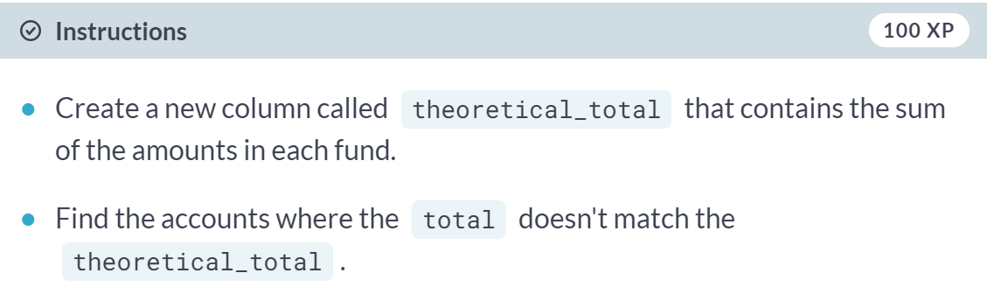

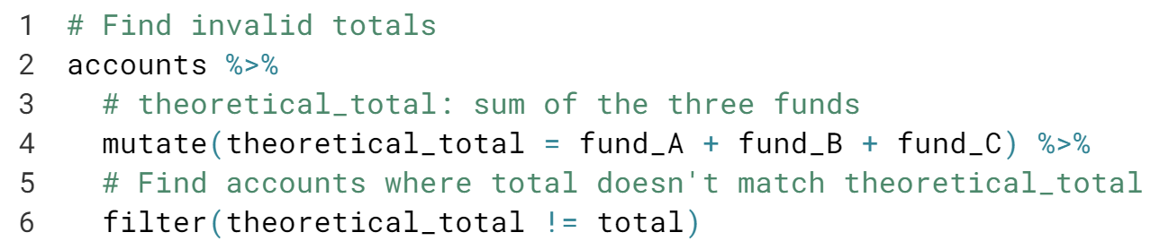

#### 

#### Great job. By using cross field validation, you've been able to detect values that don't make sense. How you choose to handle these values will depend on the dataset.

# Validating age

Now that you found some inconsistencies in the total amounts, you're suspicious that there may also be inconsistencies in the acct_age column, and you want to see if these inconsistencies are related. Using the skills you learned from the video exercise, you'll need to validate the age of each account and see if rows with inconsistent acct_ages are the same ones that had inconsistent totals

dplyr and lubridate are loaded, and accounts is available.

#### 

#### 

#### 

#### Vigorous validating! There are three accounts that all have ages off by one year, but none of them are the same as the accounts that had total inconsistencies, so it looks like these two bookkeeping errors may not be related.

#### 

#### 

#### 

#### 

#### 

#### 

#### 

#### There are 30 degrees temperature different between row 1 (present) and row 2 (missing), indicating that ozone data is missing for the days with high temperatures.

#### 

#### 

#### 

#### 

#### 

#### Types of missingness

You just learned about the three flavors of missing data: missing completely at random (MCAR), missing at random (MAR), and missing not at random (MNAR). In this exercise, you'll solidify your new knowledge by mapping examples to the types of missingness.

#### 

#### 

#### 

#### 

# Visualizing missing data

Dealing with missing data is one of the most common tasks in data science. There are a variety of types of missingness, as well as a variety of types of solutions to missing data.

You just received a new version of the accounts data frame containing data on the amount held and amount invested for new and existing customers. However, there are rows with missing inv_amount values.

You know for a fact that most customers below 25 do not have investment accounts yet, and suspect it could be driving the missingness. The dplyr and visdat packages have been loaded and accounts is available.

#### 

#### 

#### 

#### 

#### 

#### 

#### 

#### 

#### 

#### Fabulous visualizations! Investigating summary statistics based on missingness is a great way to determine if data is missing completely at random or missing at random.

# Treating missing data

In this exercise, you're working with another version of the accounts data that contains missing values for both the cust_id and acct_amount columns.

You want to figure out how many unique customers the bank has, as well as the average amount held by customers. You know that rows with missing cust_id don't really help you, and that on average, the acct_amount is usually 5 times the amount of inv_amount.

In this exercise, you will drop rows of accounts with missing cust_ids, and impute missing values of inv_amount with some domain knowledge. dplyr and assertive are loaded and accounts is available.

#### 

#### 

#### 

#### 

#### 

#### 

#### 

#### 

#### 

#### 

#### Great job! Since your assertions passed, there's no missing data left, and you can bank on nailing your analysis!

#### Record Linkage Record linkage is a powerful technique used to merge multiple datasets together, used when values have typos or different spellings. In this chapter, you'll learn how to link records by calculating the similarity between strings—you’ll then use your new skills to join two restaurant review datasets into one clean master dataset.

#### 

#### 

#### 

#### 

#### 

#### 

#### 

#### 

#### 

#### 

#### 

# Calculating distance

In the video exercise, you saw how to use Damerau-Levenshtein distance to identify how similar two strings are. As a reminder, Damerau-Levenshtein distance is the minimum number of steps needed to get from **String A** to **String B**, using these operations:

* **Insertion** of a new character.
* **Deletion** of an existing character.
* **Substitution** of an existing character.
* **Transposition** of two existing consecutive characters.

What is the Damerau-Levenshtein distance between the words "puffin" and "muffins" and which operation(s) gets you there?

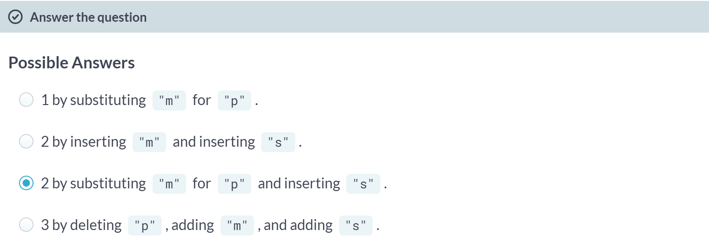

Crafty calculations! Substituting and inserting is the best way to get from "puffin" to "muffins". In the next exercise, you'll calculate string distances using R functions.

# Small distance, small difference

In the video exercise, you learned that there are multiple ways to calculate how similar or different two strings are. Now you'll practice using the stringdist package to compute string distances using various methods. It's important to be familiar with different methods, as some methods work better on certain datasets, while others work better on other datasets.

The stringdist package has been loaded for you.

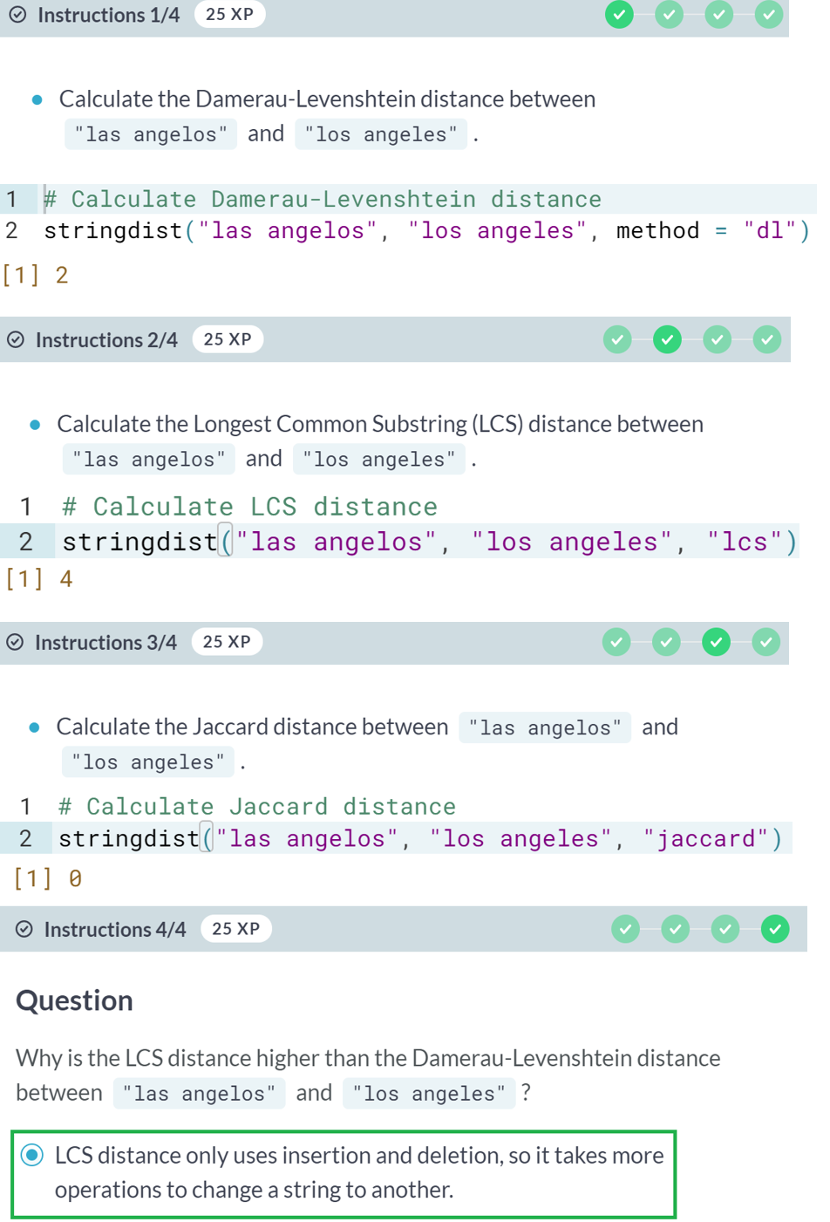

# Fixing typos with string distance

In this chapter, one of the datasets you'll be working with, zagat, is a set of restaurants in New York, Los Angeles, Atlanta, San Francisco, and Las Vegas. The data is from Zagat, a company that collects restaurant reviews, and includes the restaurant names, addresses, phone numbers, as well as other restaurant information.

The city column contains the name of the city that the restaurant is located in. However, there are a number of typos throughout the column. Your task is to map each city to one of the five correctly-spelled cities contained in the cities data frame.

dplyr and fuzzyjoin are loaded, and zagat and cities are available.

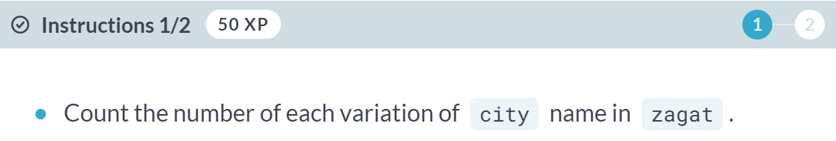

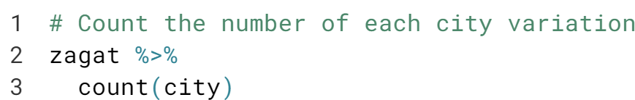

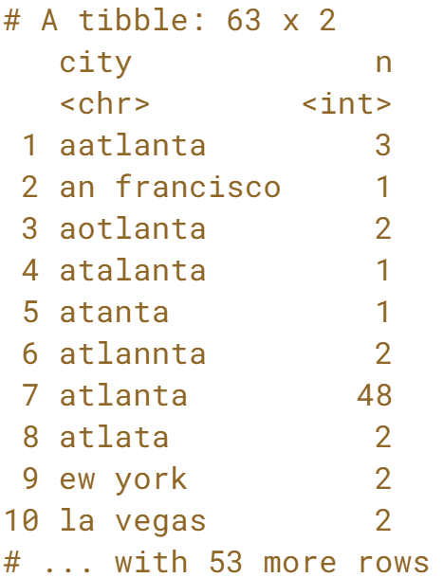

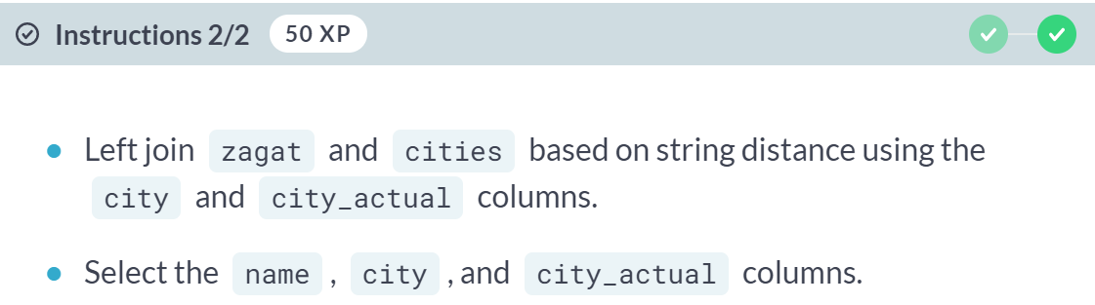

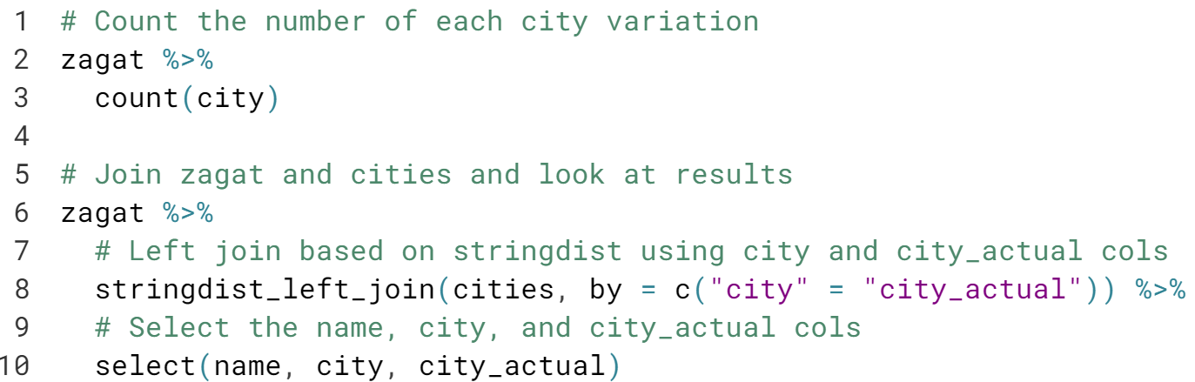

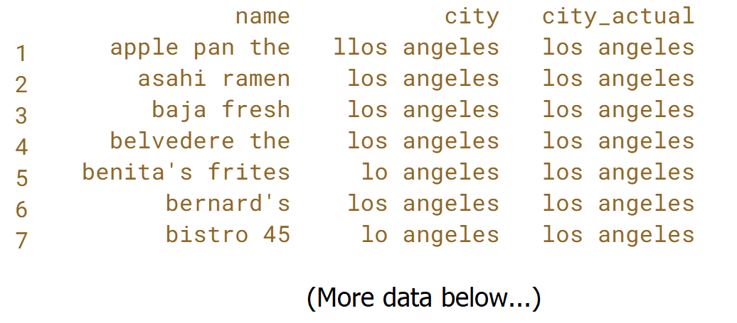

(I don’t understand why the function ***stringdist_left_join*** is used)



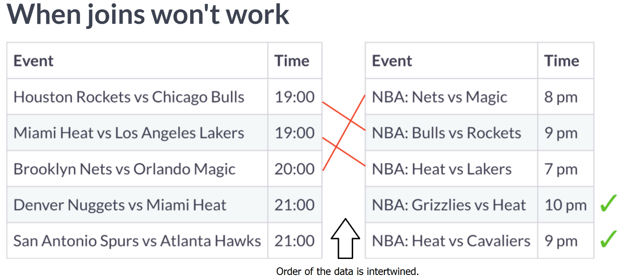

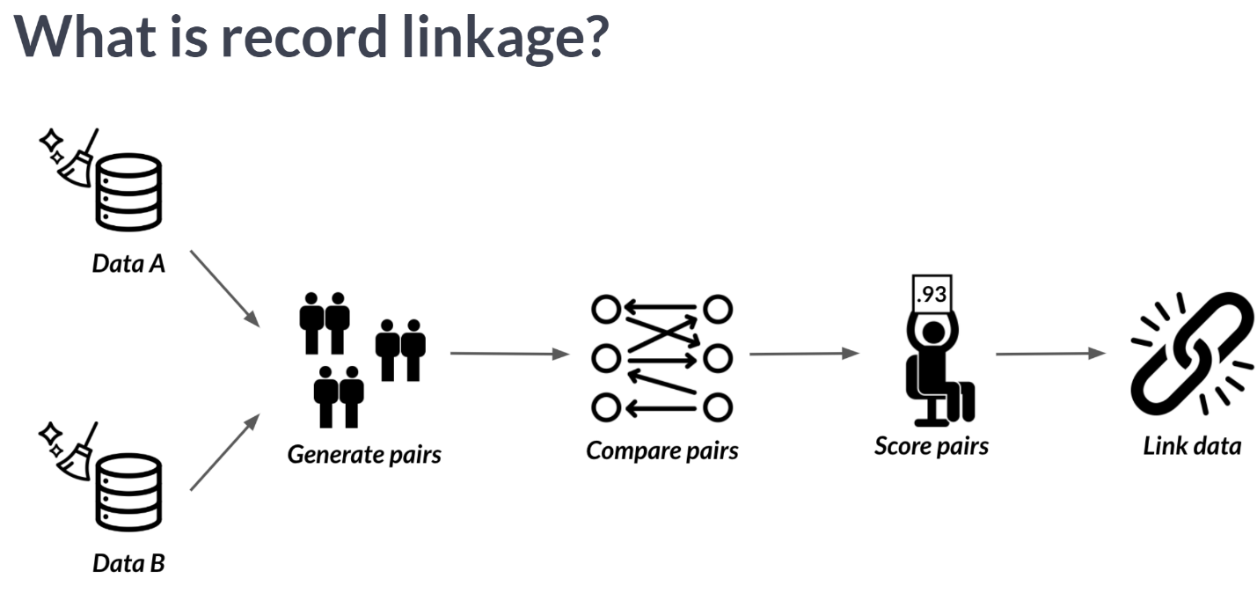

#### 

#### 

#### 

#### 

#### 

#### 

#### 

#### 

#### 

#### 

#### Link or join?

Similar to joins, record linkage is the act of linking data from different sources regarding the same entity. But unlike joins, record linkage does not require exact matches between different pairs of data, and instead can find close matches using string similarity. This is why record linkage is effective when there are no common unique keys between the data sources you can rely upon when linking data sources such as a unique identifier.

In this exercise, you will decide which method is the best course of action to solve each problem.

#### 

#### 

#### Don't make things more complicated than they need to be: record linkage is a powerful tool, but it's more complex than using a traditional join.

# Pair blocking

Zagat and Fodor's are both companies that gather restaurant reviews. The zagat and fodors datasets both contain information about various restaurants, including addresses, phone numbers, and cuisine types. Some restaurants appear in both datasets, but don't necessarily have the same exact name or phone number written down. In this chapter, you'll work towards figuring out which restaurants appear in both datasets.

The first step towards this goal is to generate pairs of records so that you can compare them. In this exercise, you'll first generate all possible pairs, and then use your newly-cleaned city column as a blocking variable.

zagat and fodors are available.

#### 

#### 

#### 

#### 

#### 

#### 

#### Perfect pairings! By using city as a blocking variable, you were able to reduce the number of pairs you'll need to compare from 165,230 pairs to 40,532.

# Comparing pairs

Now that you've generated the pairs of restaurants, it's time to compare them. You can easily customize how you perform your comparisons using the by and default_comparator arguments. There's no right answer as to what each should be set to, so in this exercise, you'll try a couple options out.

dplyr and reclin are loaded and zagat and fodors are available.

#### 

#### 

#### 

#### 

#### 

#### 

#### Crafty comparisons! Choosing a comparator and the columns to compare is highly dataset-dependent, so it's best to try out different combinations to see which works best on the dataset you're working with. Next, you'll build on your string comparison skills and learn about record linkage!

#### 

#### 

#### 

#### 

#### 

#### 

#### 

#### 

#### 

#### 

#### Score then select or select then score?

Record linkage requires a number of steps that can be difficult to keep straight. In this exercise, you'll solidify your knowledge of the record linkage process so that it's a breeze when you code it yourself!

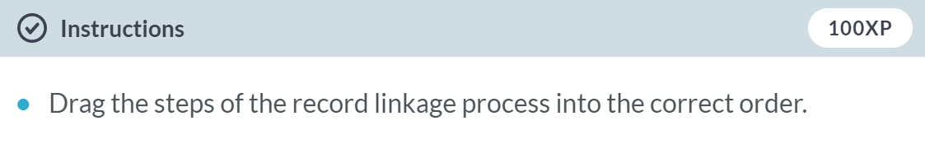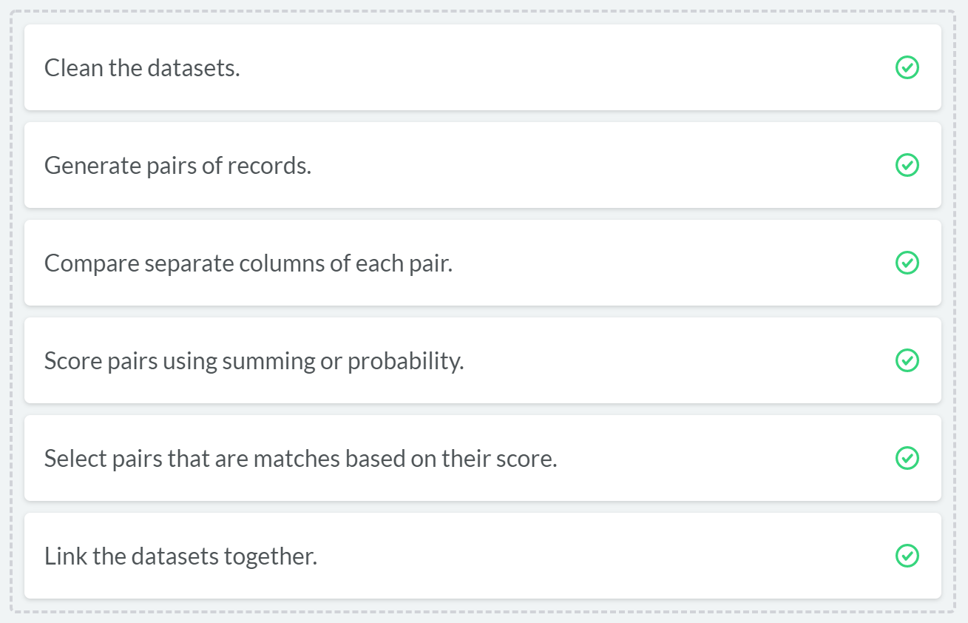

# Putting it together

During this chapter, you've cleaned up the city column of zagat using string similarity, as well as generated and compared pairs of restaurants from zagat and fodors. The end is near - all that's left to do is score and select pairs and link the data together, and you'll be able to begin your analysis in no time!

reclin and dplyr are loaded and zagat and fodors are available.

#### 

#### 

#### 

#### 

#### 

#### 

#### 

#### 

#### 

#### Now that your two datasets are merged, you can use the data to figure out if there are certain characteristics that make a restaurant more likely to be reviewed by Zagat or Fodor's.

#### 

#### 

#### 

#### 

#### 